Assembling the Badge

1. Front view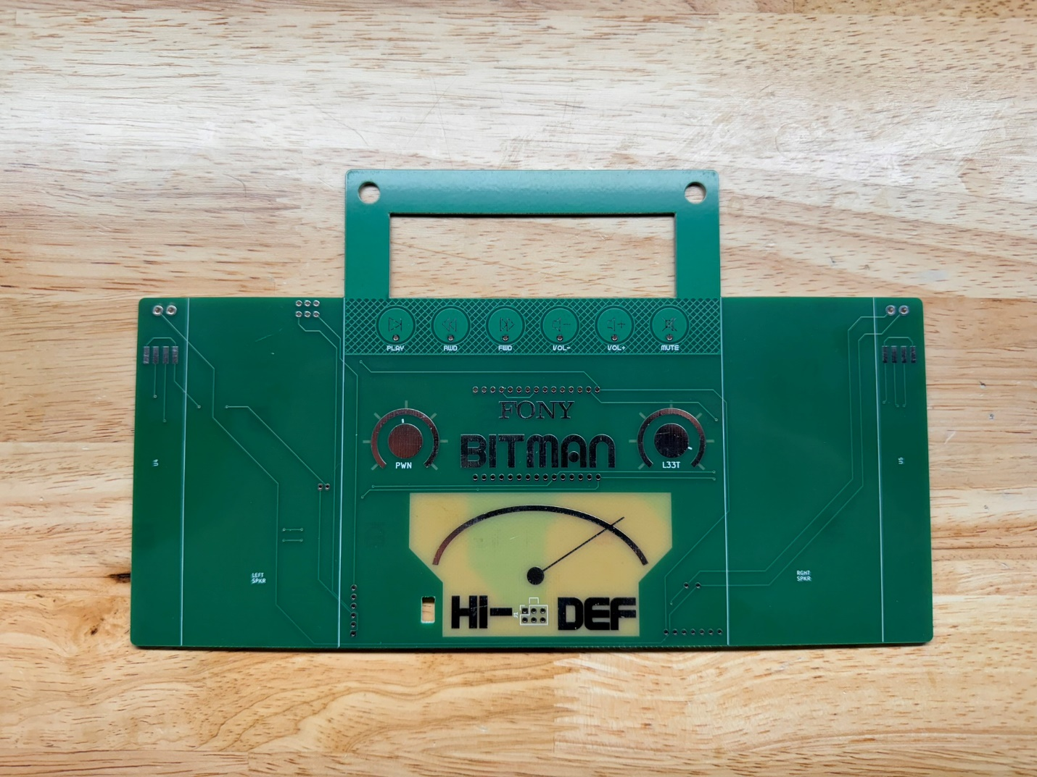
2. Rear view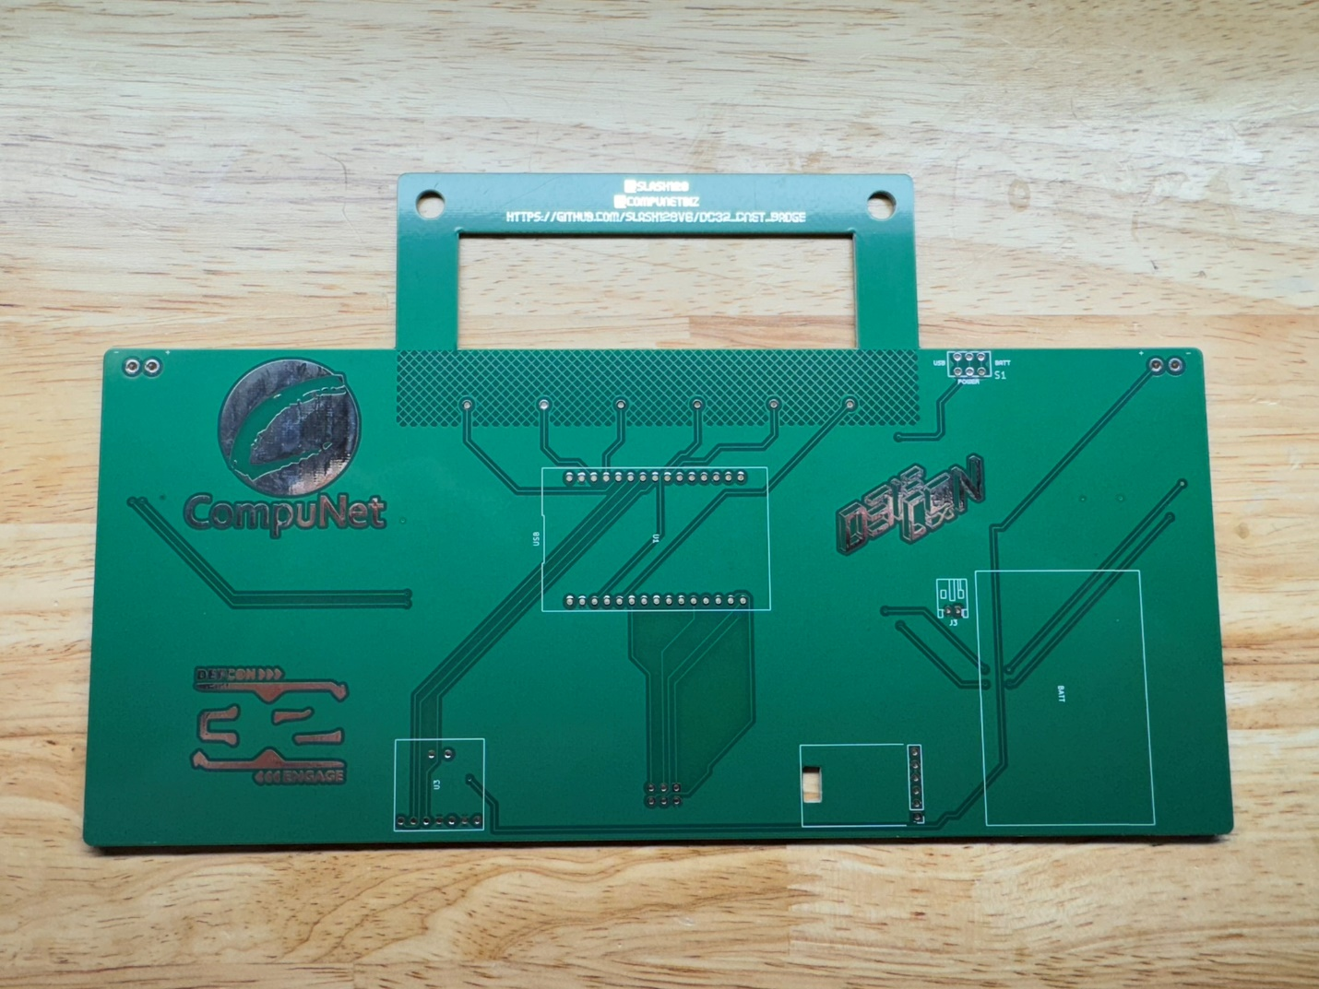
3. Solder the LED strips to the front of the badge. The DI (Data In) side connects to the badge pads.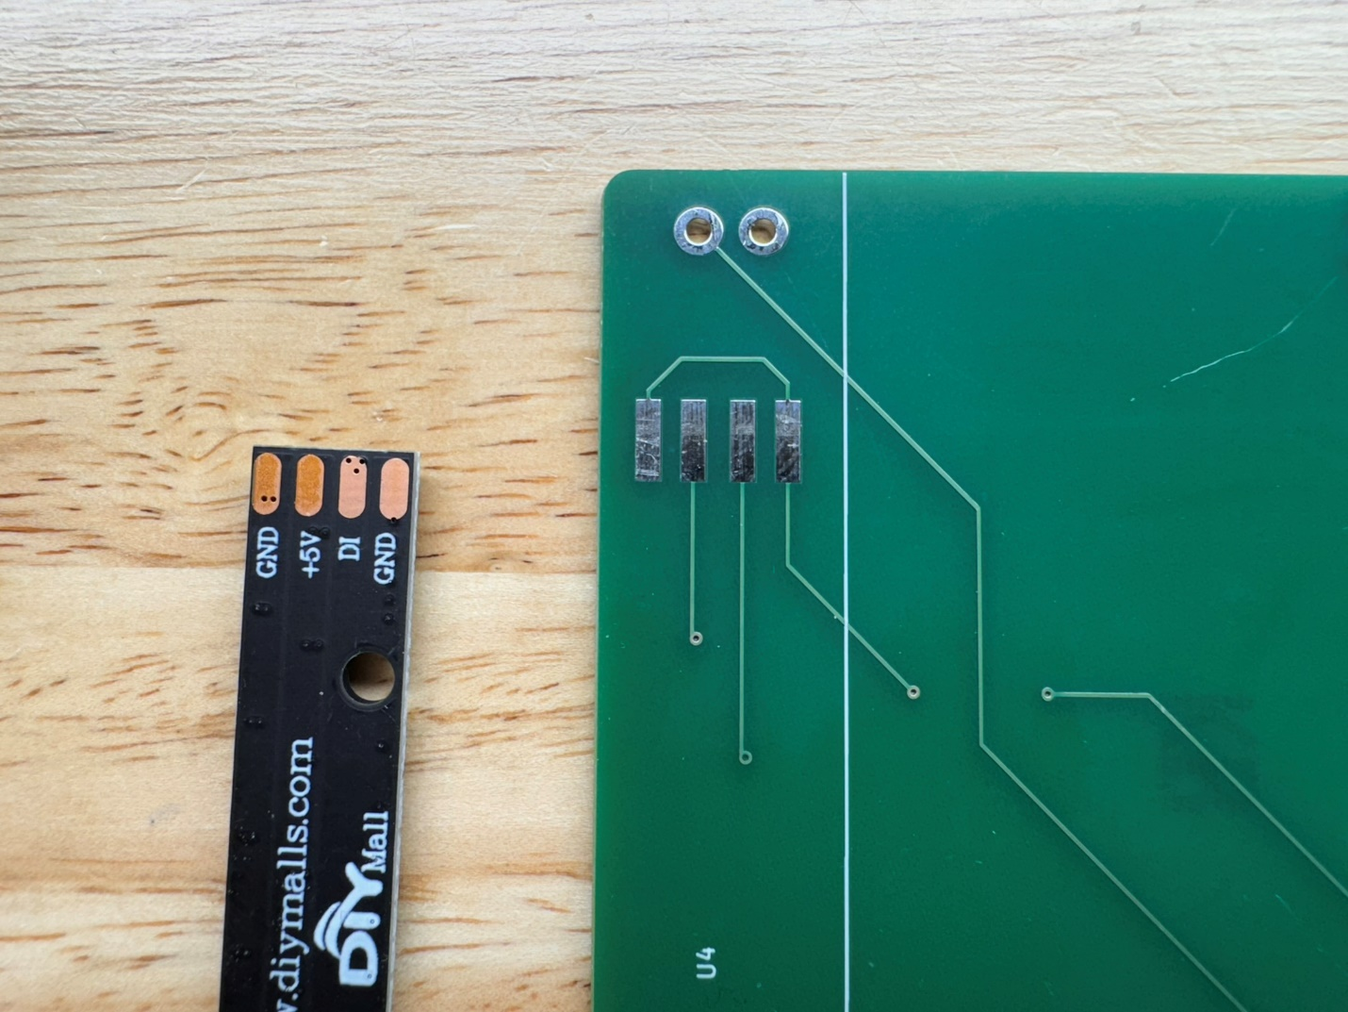
4. Start by tinning the LED strip pads and the badge pads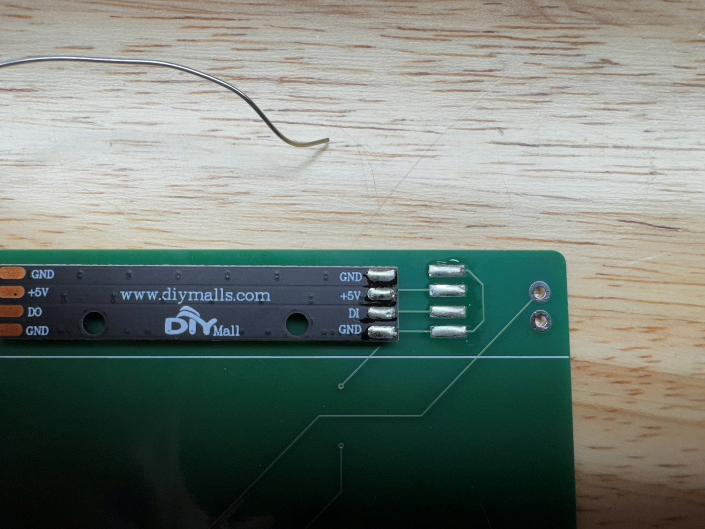
5. Line up the LED strip pads on the badge pads leaving the ends of the badge pads exposed so you can heat them up with your soldering iron. It’s a little tricky but you should be able to get the solder to flow and insert some solder from the sides of the pads to connect the pads. Try to keep the LED strip straight.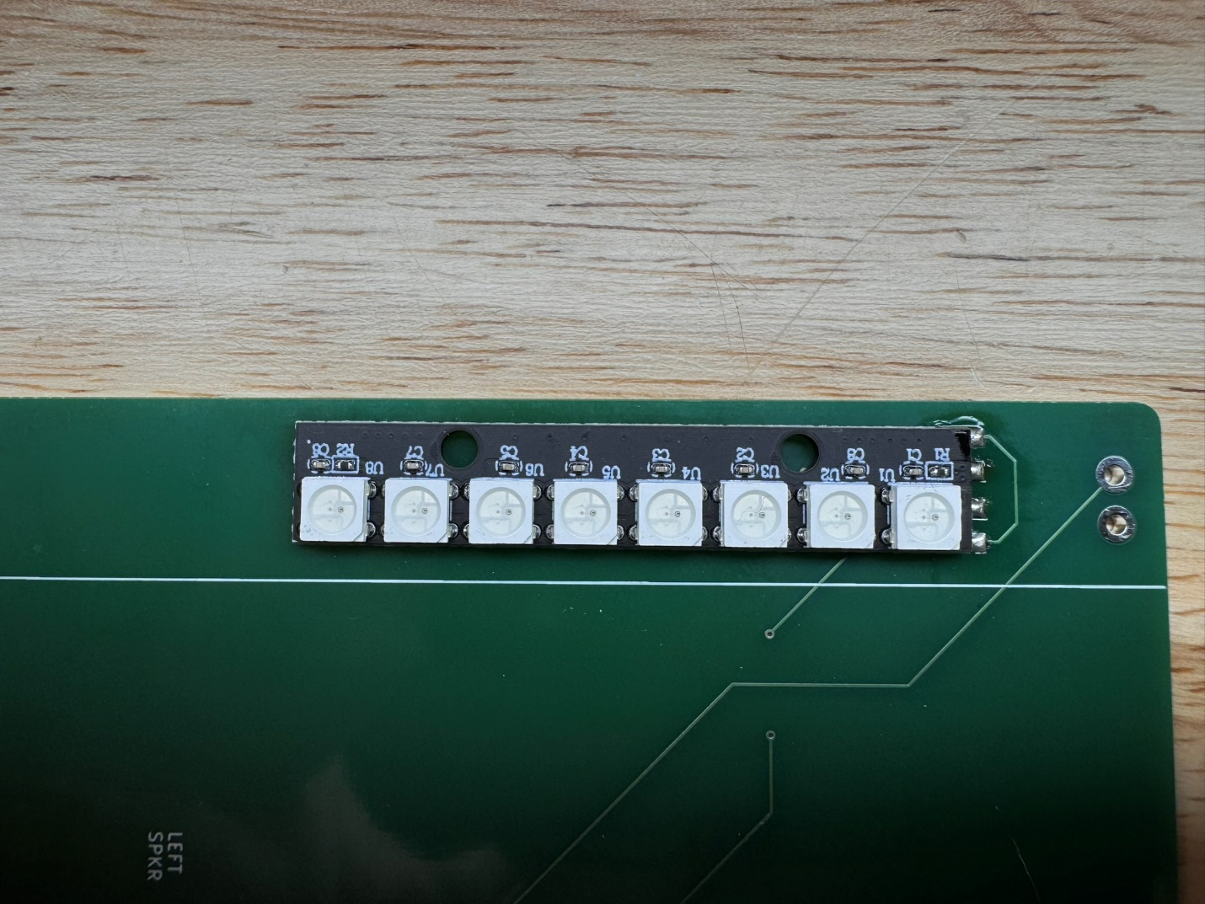
6. Repeat for the second LED strip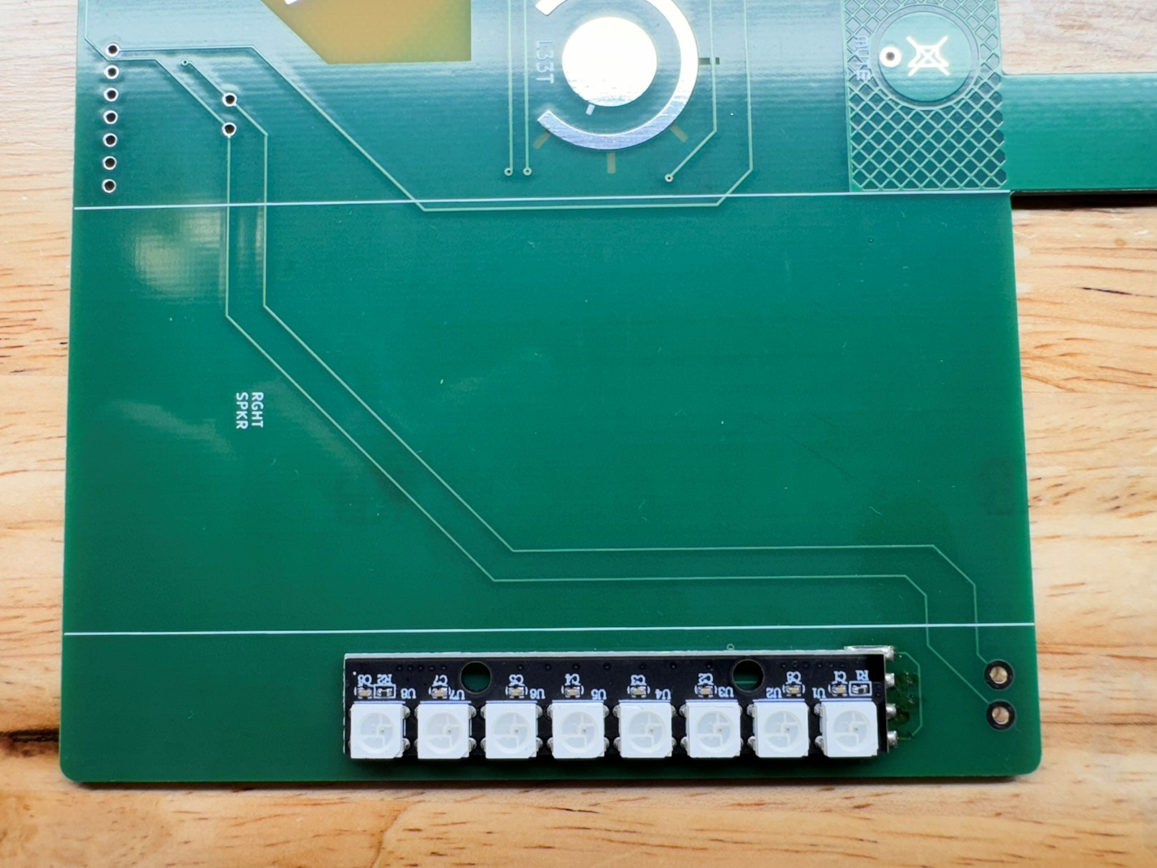
7. Solder the power switch on the back with the switch tab facing up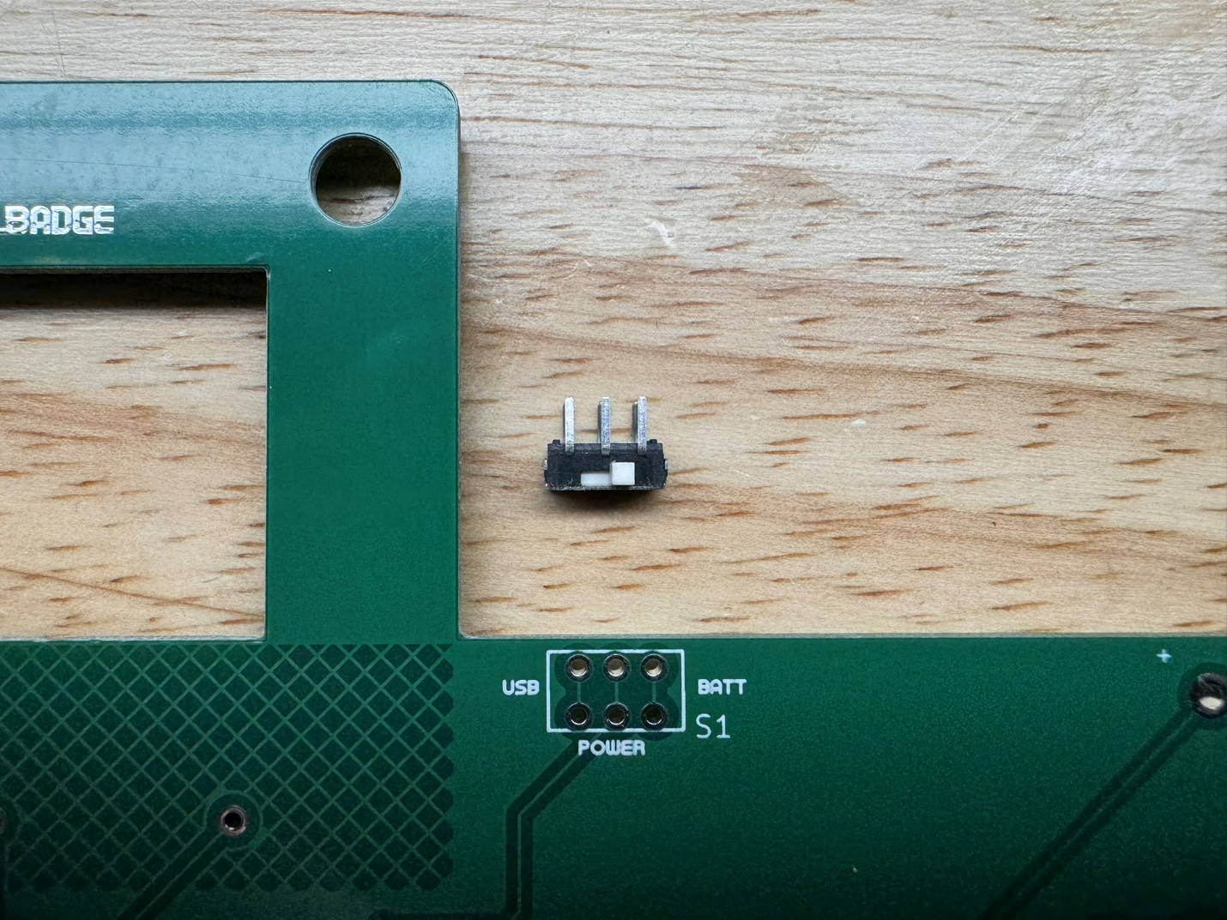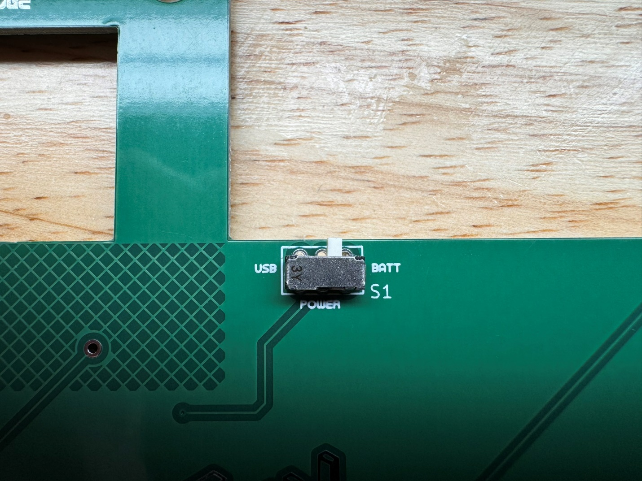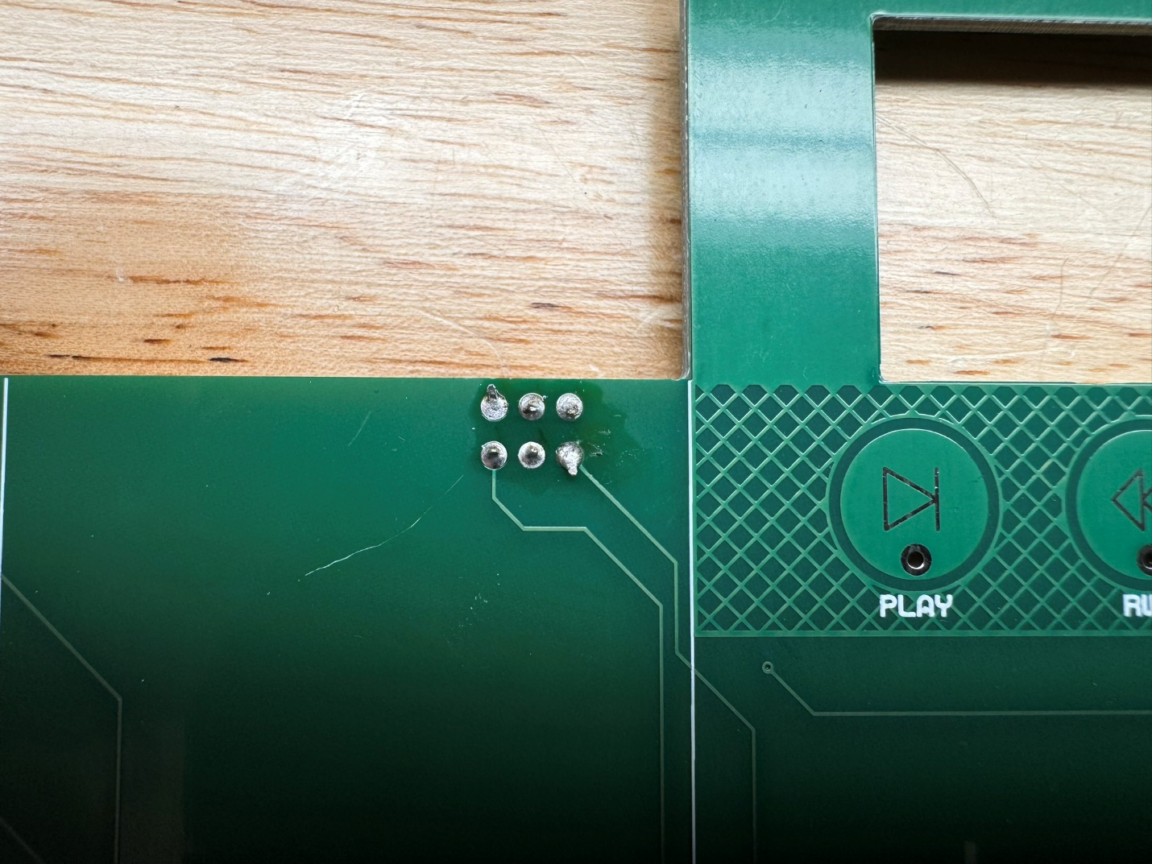
8. Solder the SAO connector with the tab up matching the outline keeping it straight and parallel to the bottom oedge of the badge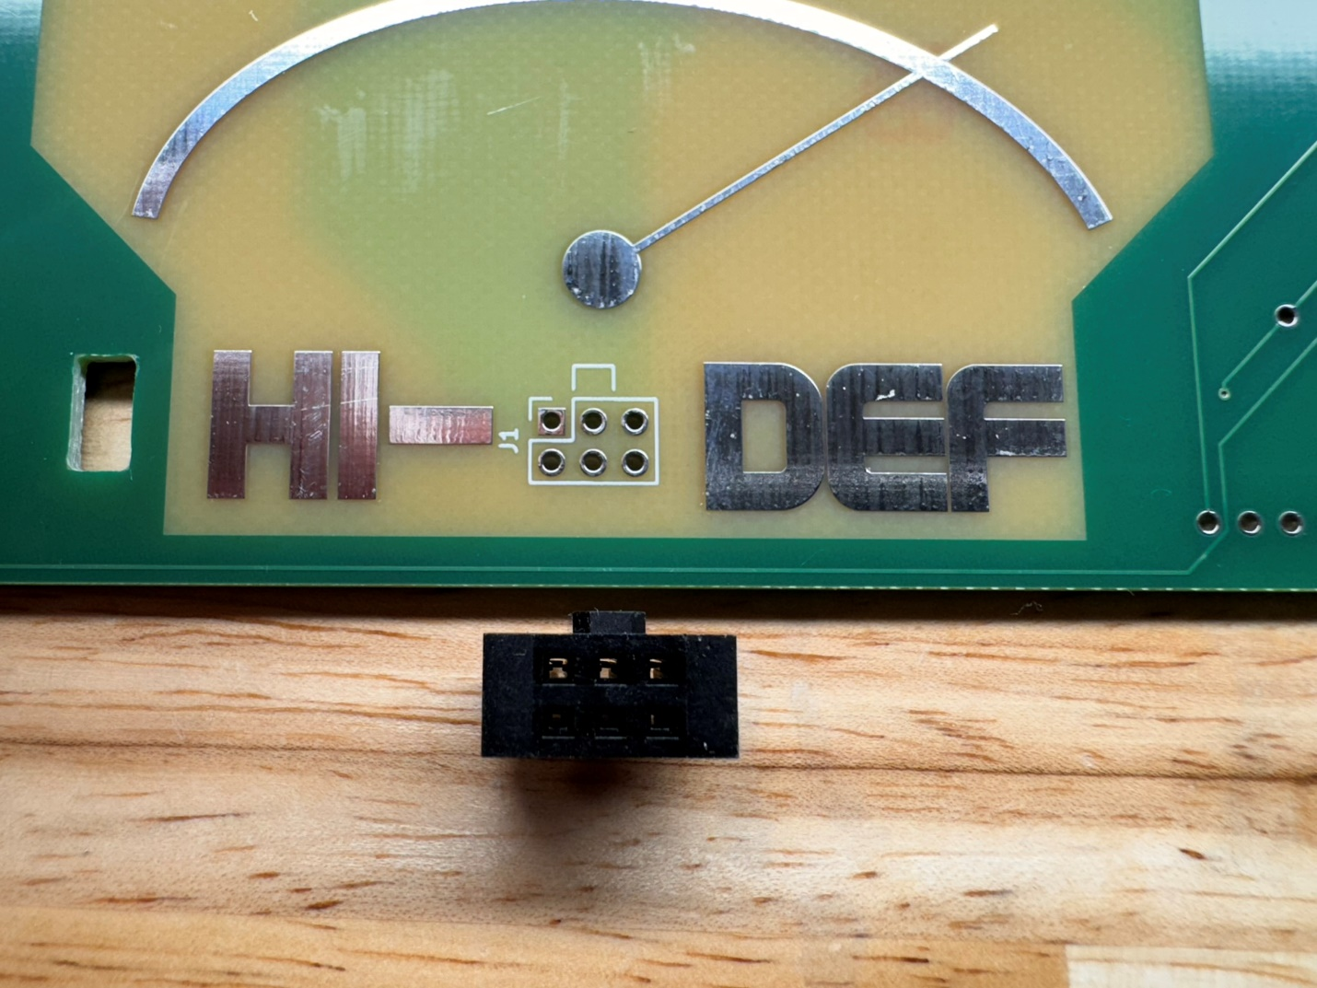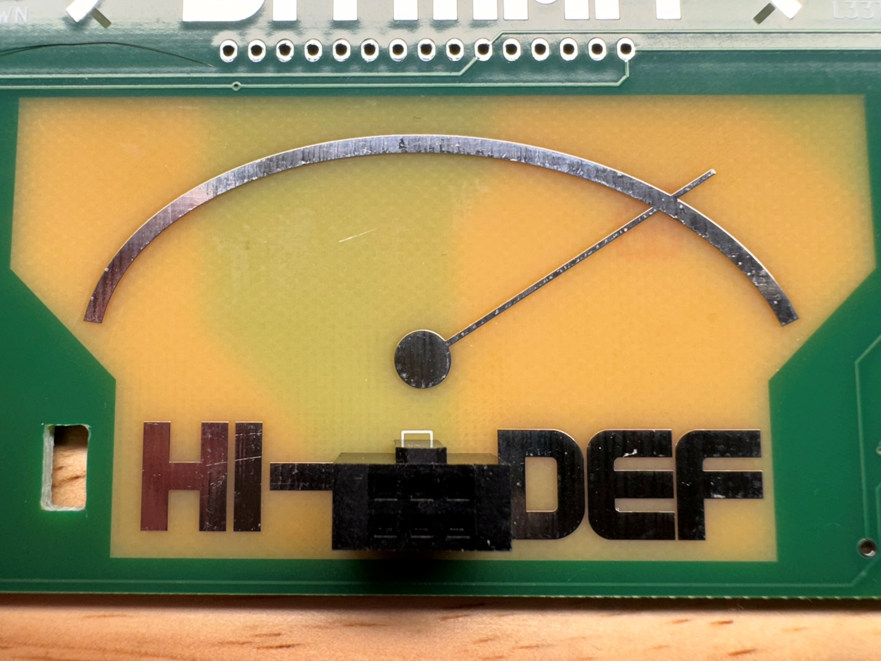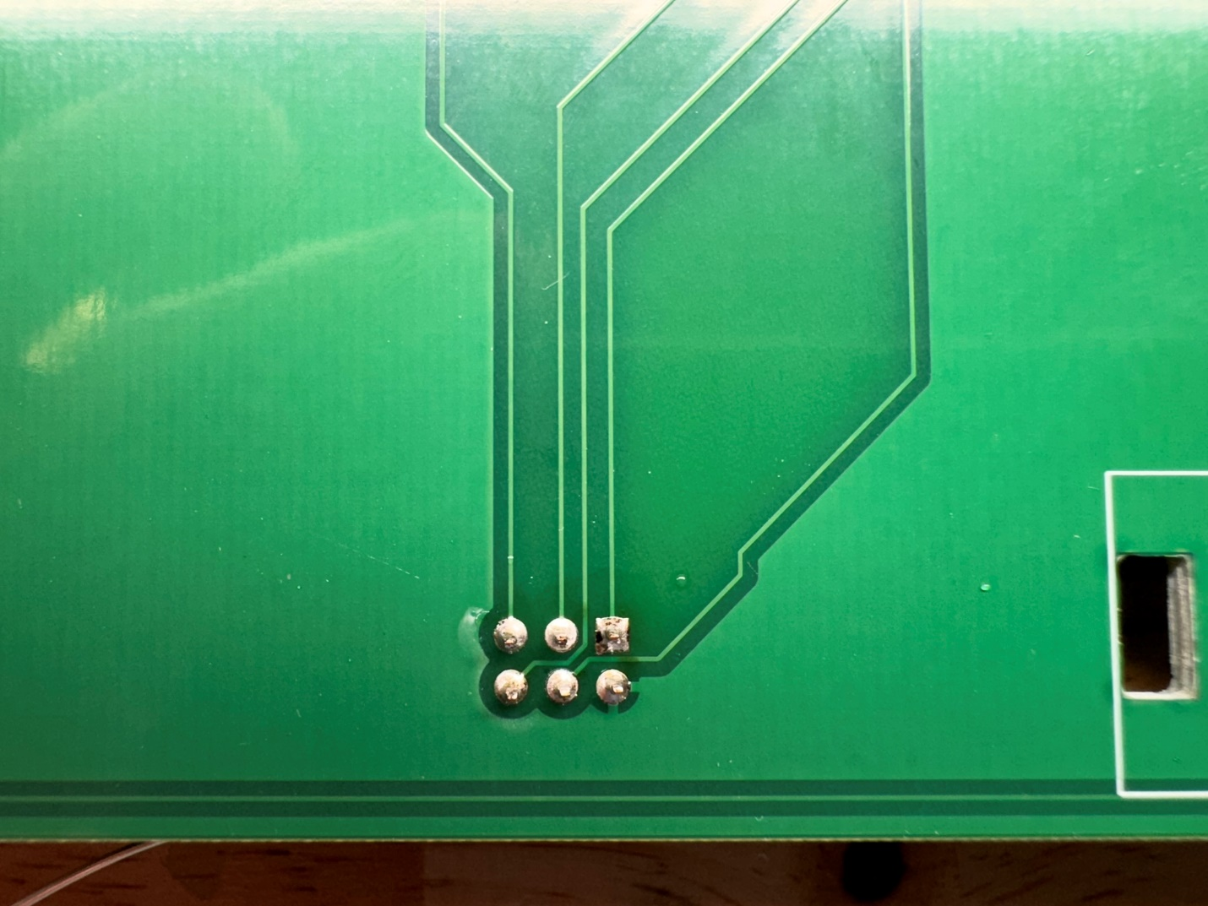
9. Locate the battery charger module and pin header and cut off 6 pins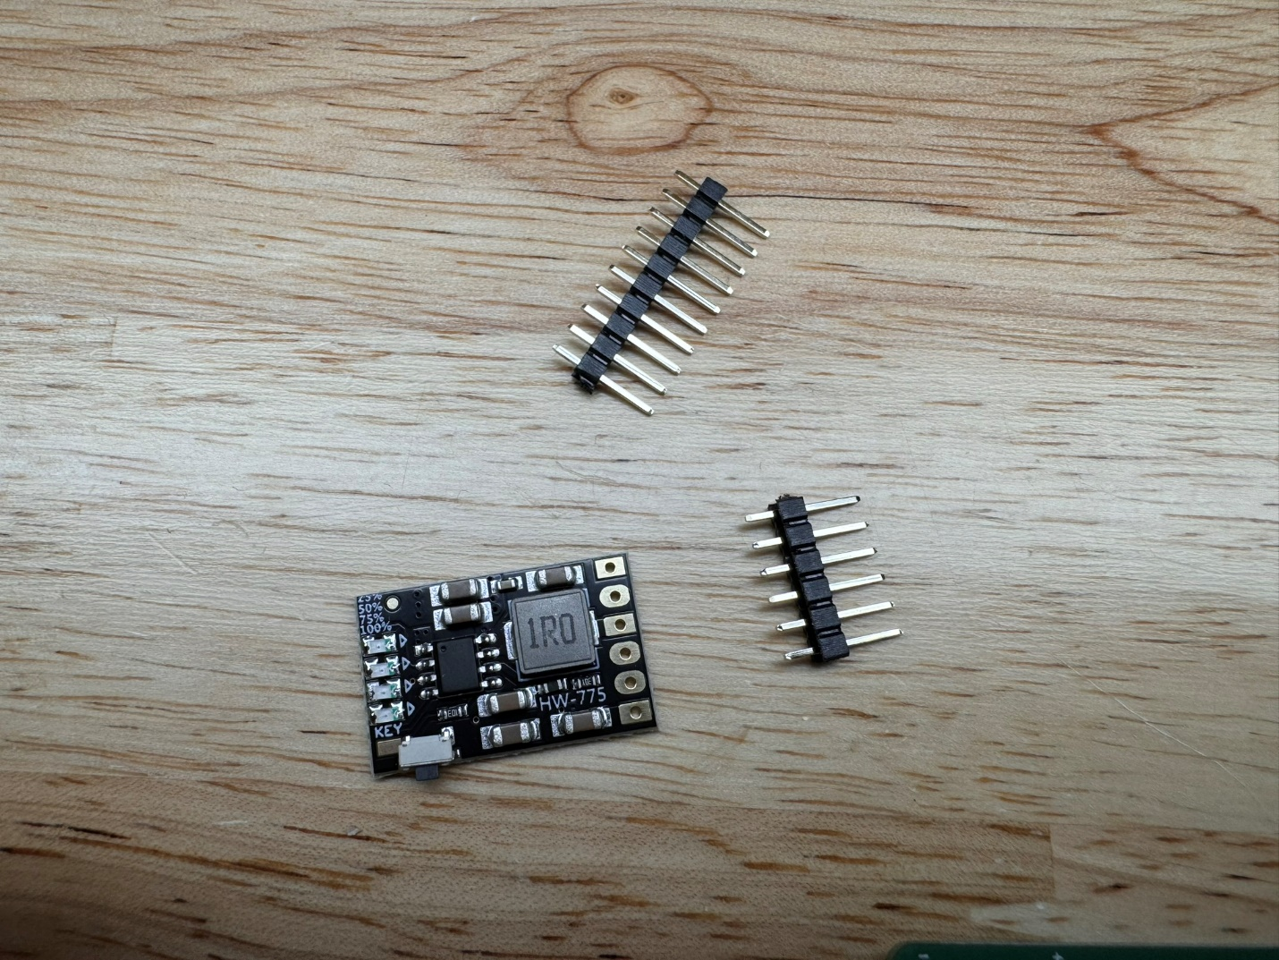
10. Solder the 6 pin header to the charge module with the short pins protruding through the white silkscreen side of the charge module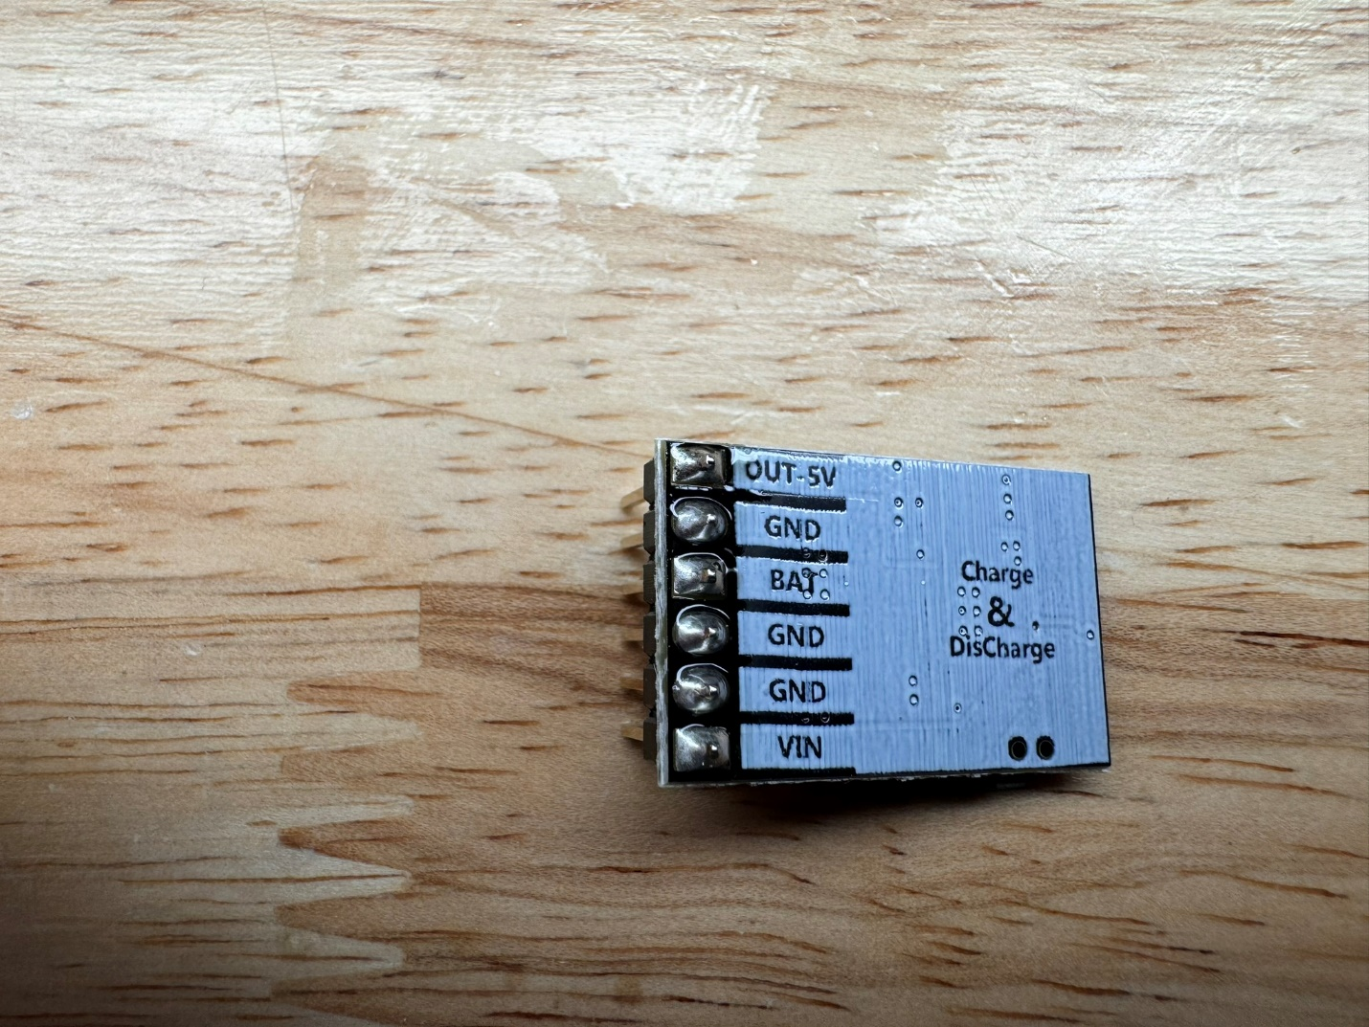
11. Solder the charge module to the back of the badge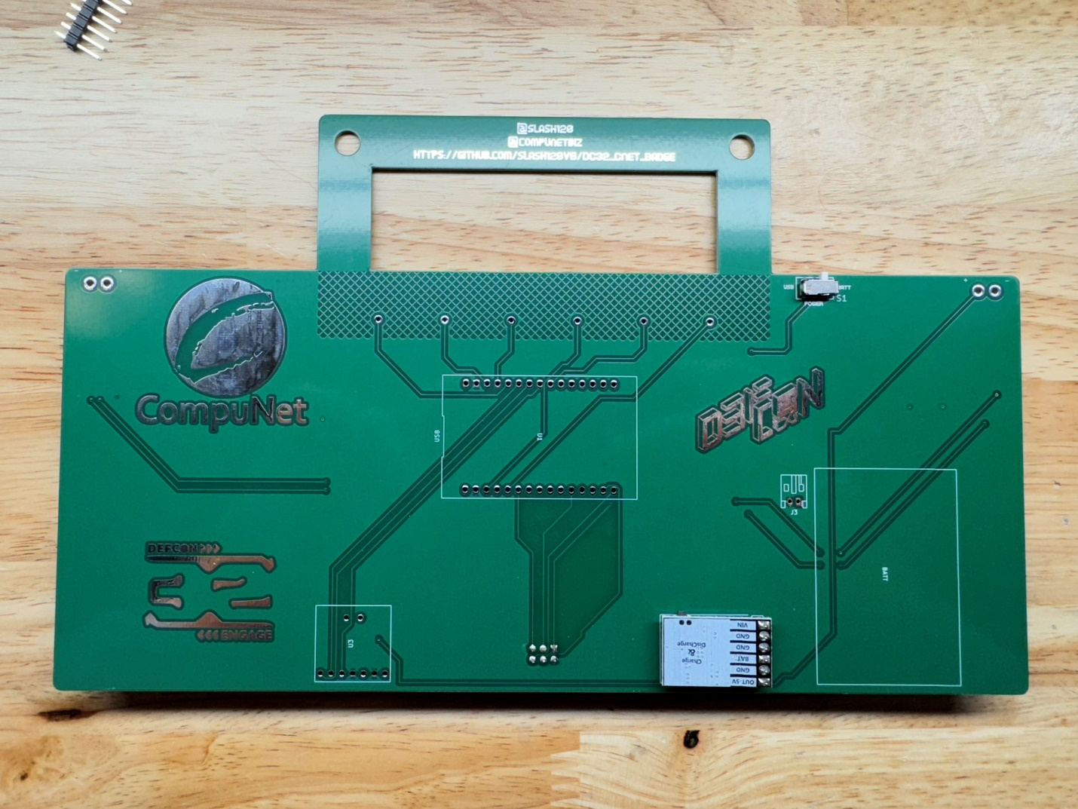
12. The charge module battery level LEDs should be visibile through the front of the badge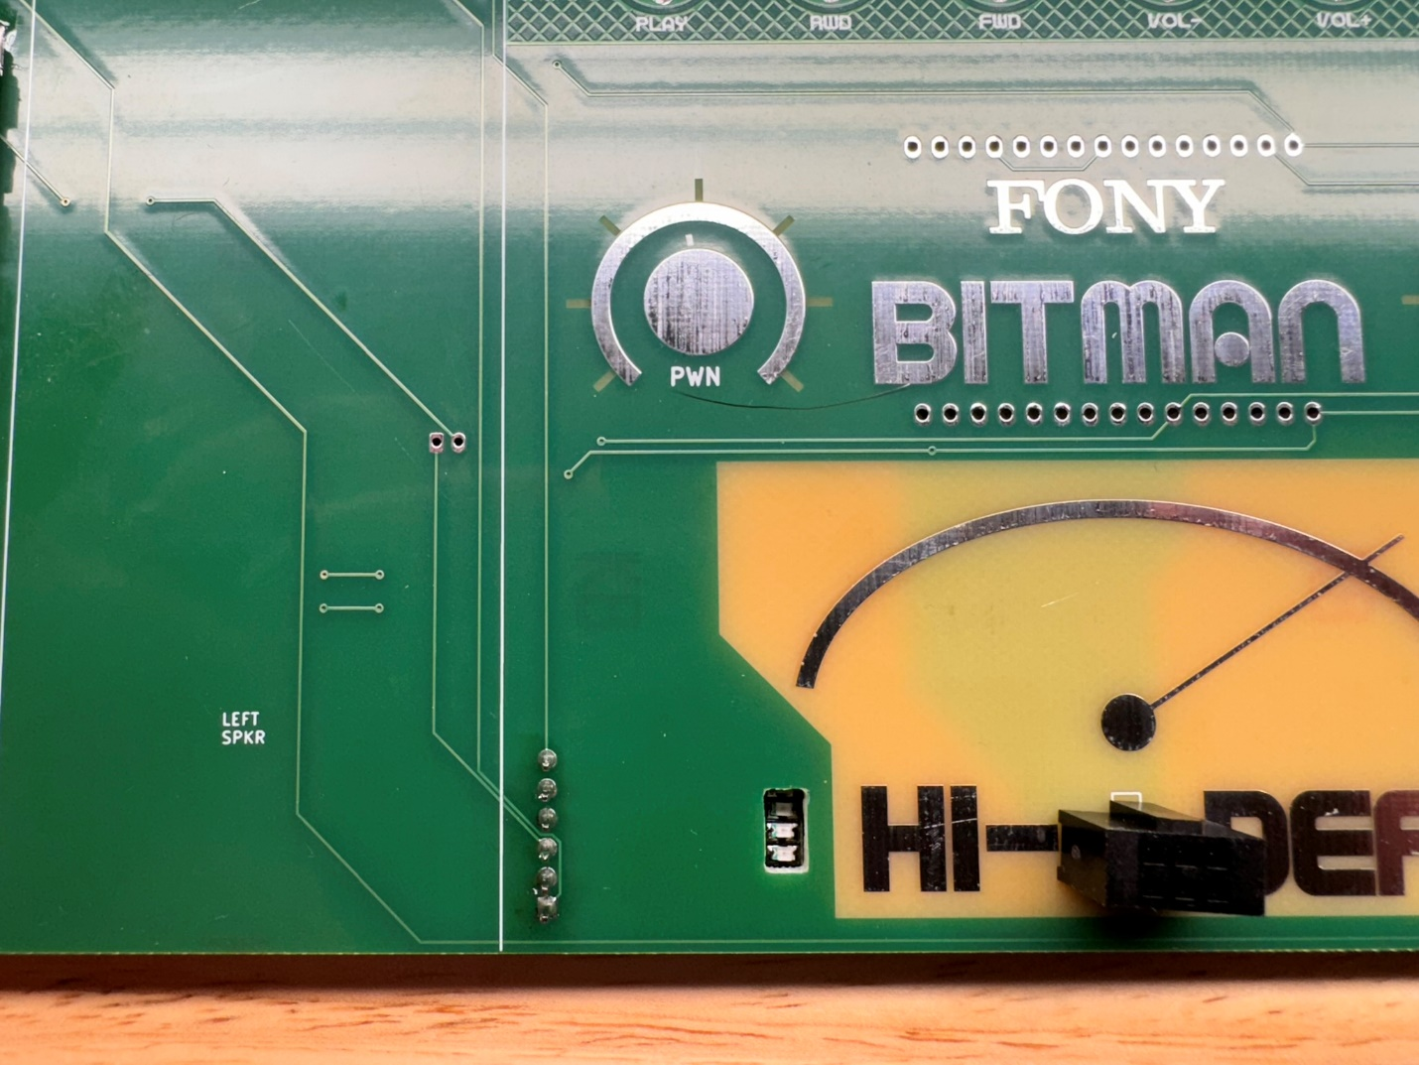
13. Locate the amplifier module and pin header, the green screw terminal is not needed and can be discarded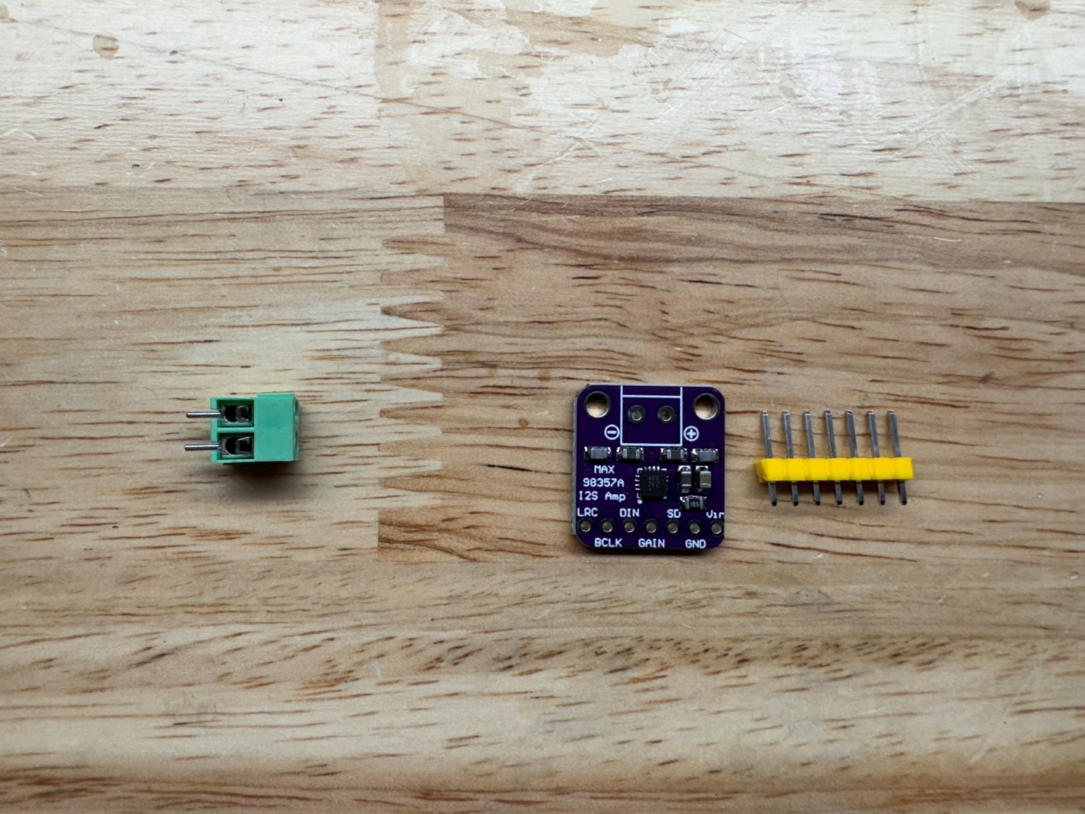
14. Solder the pin header to the amplifier with the short side of the pins protruding through the silkscreen pin label side of the amplifier module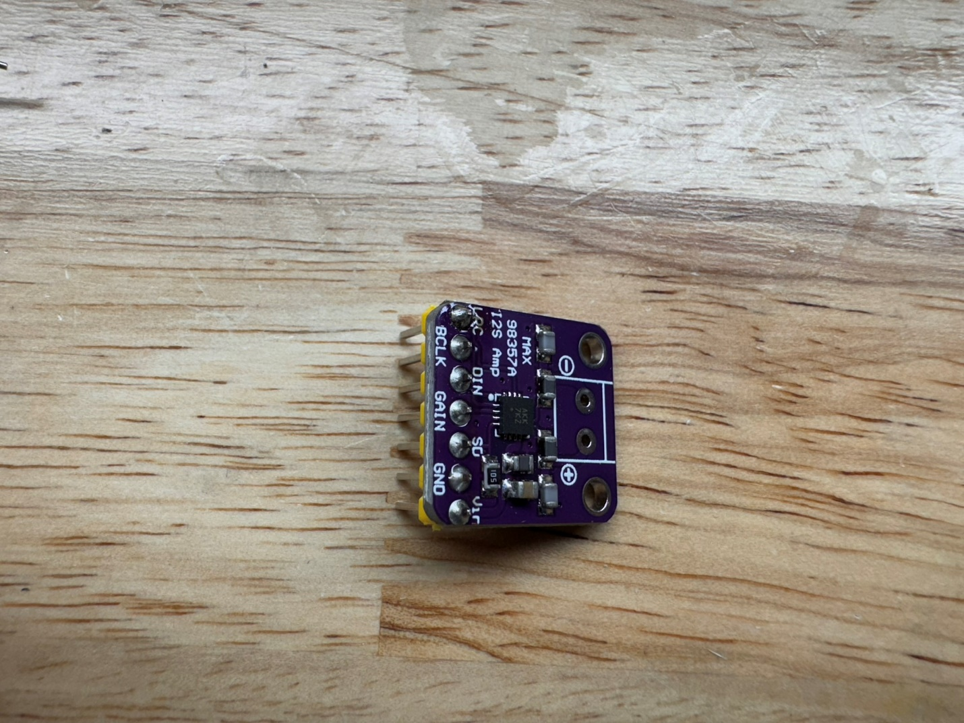
15. Cut 2 more single pins and solder them to the speaker outputs with the short side protruding through the silkscreen pin label side of the amplifier module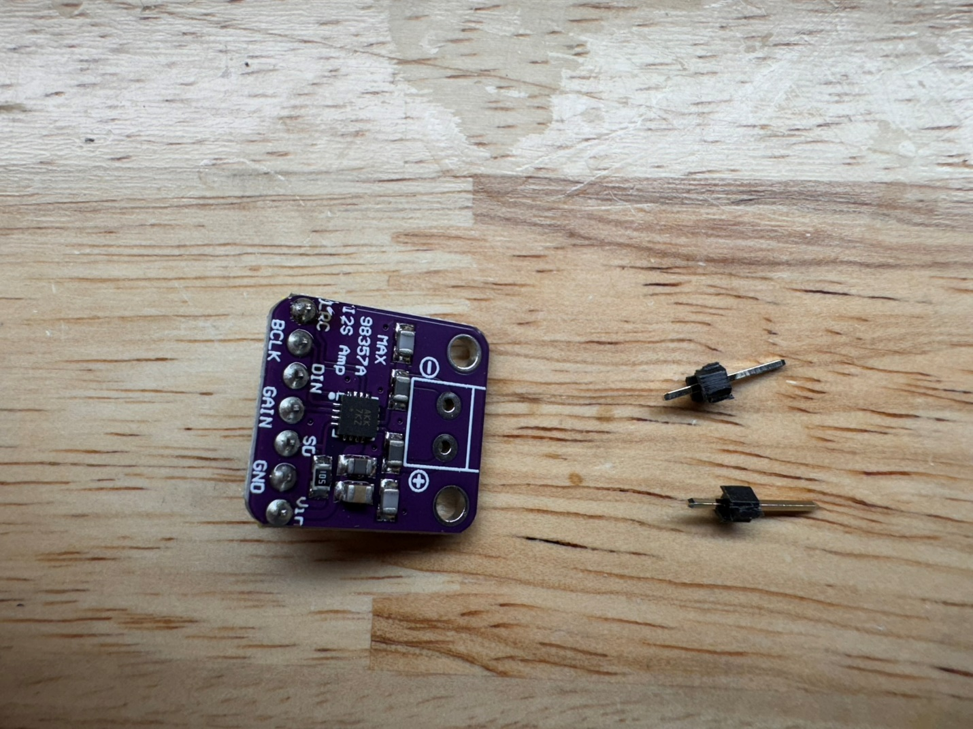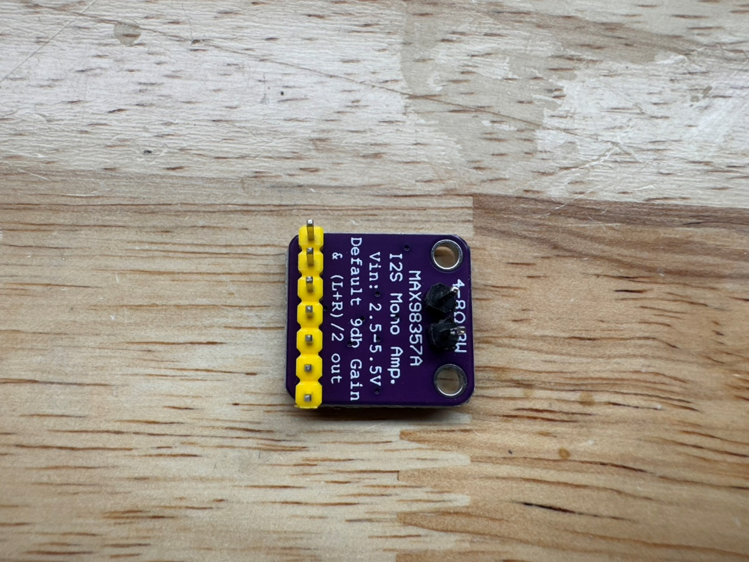
16. Solder the amplifier module through the back of the badge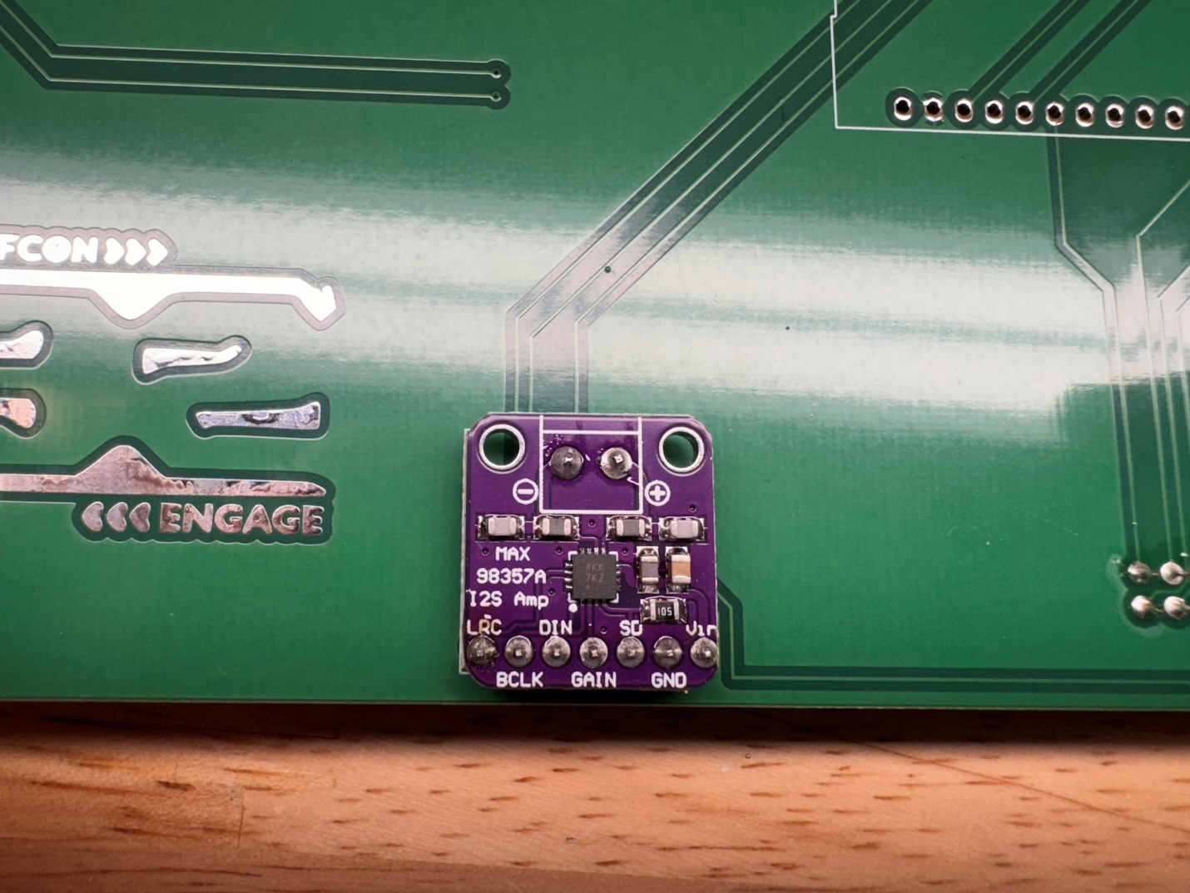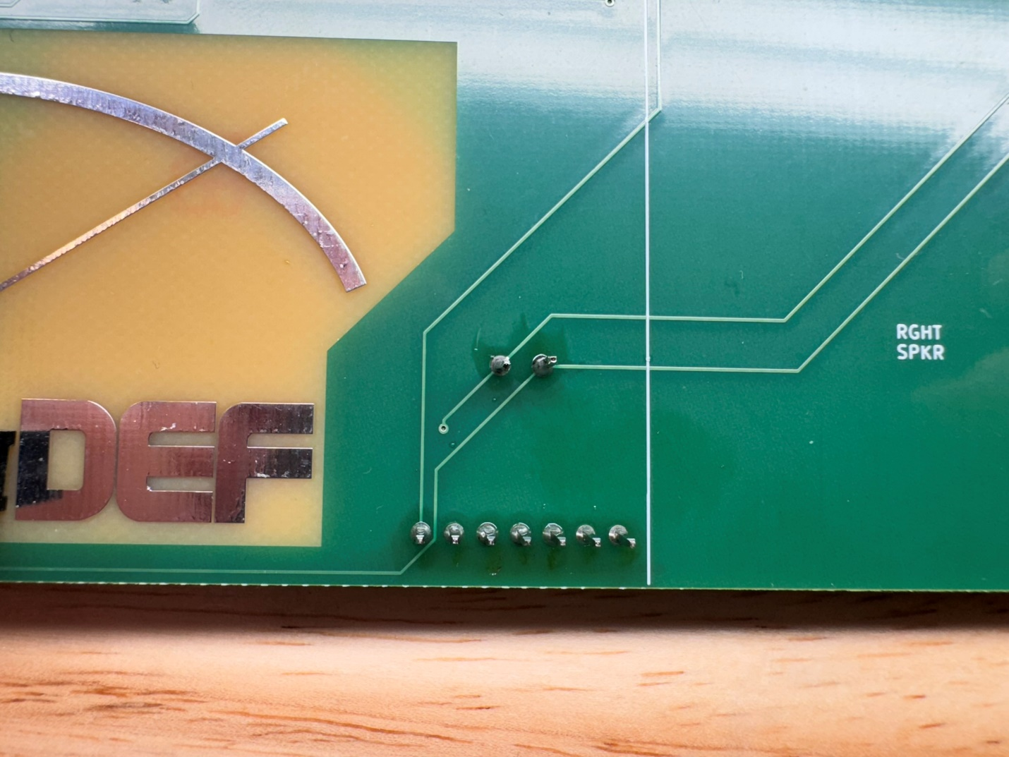
17. Solder the ESP32 module to the back of the badge with the USB connector oriented to the silkscreen outline which should face the CompuNet logo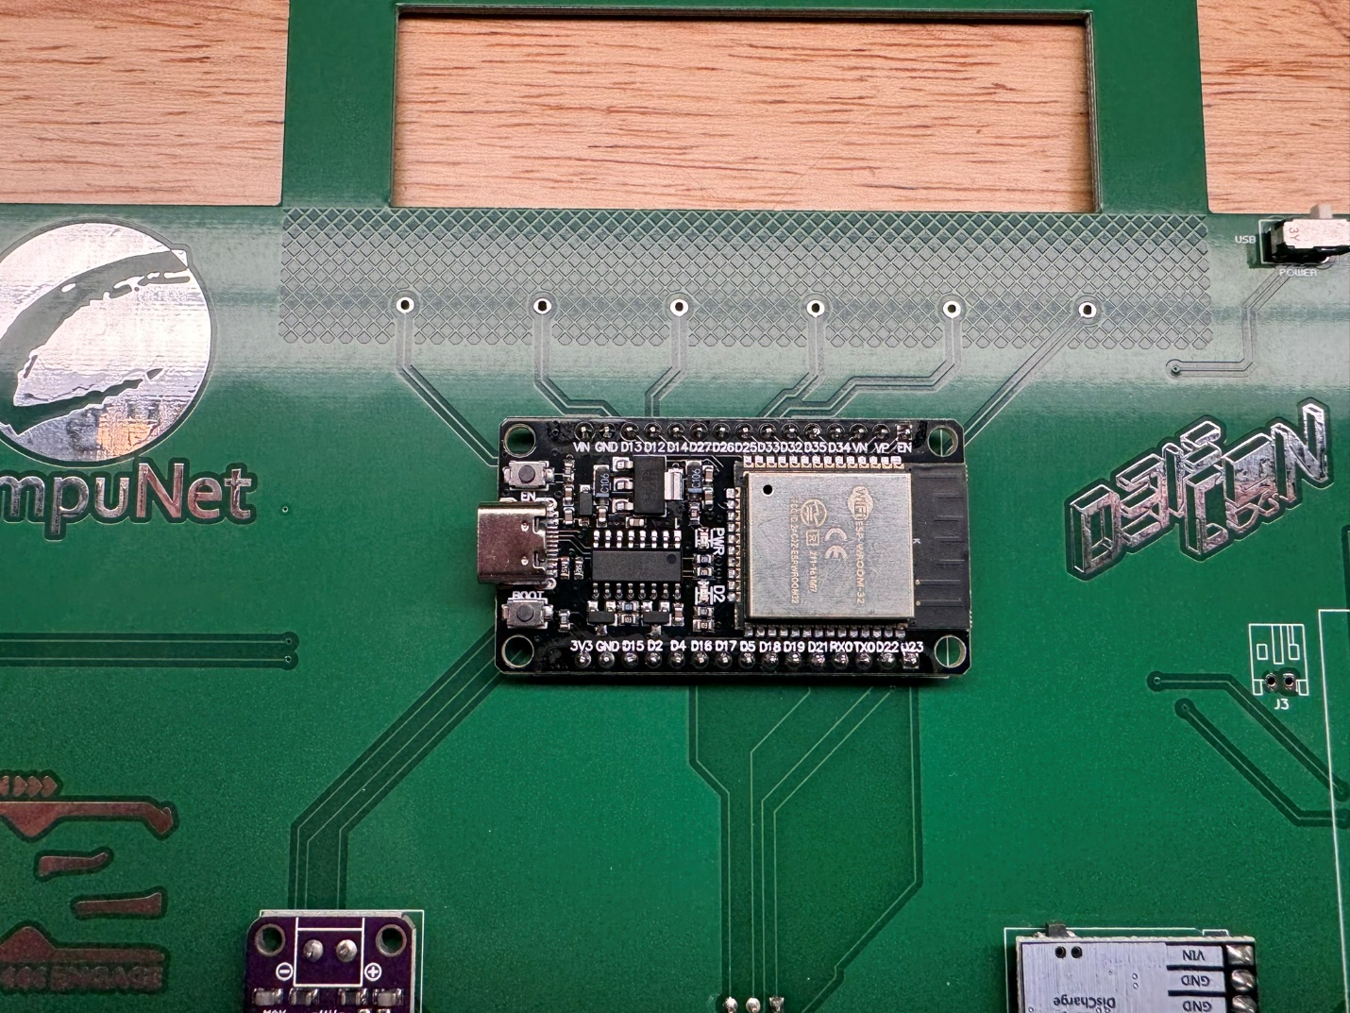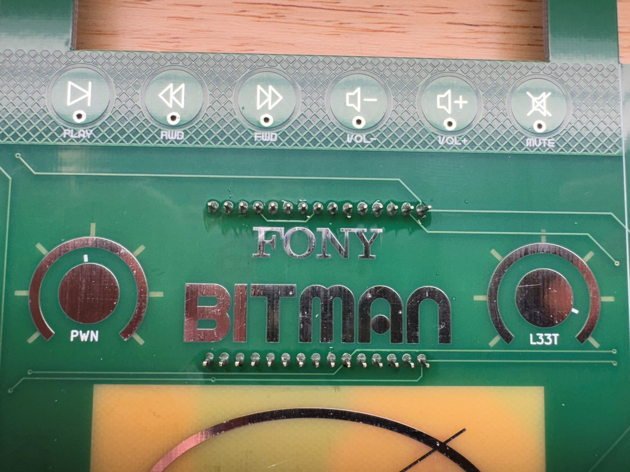
18. Solder the battery connector to the back of the badge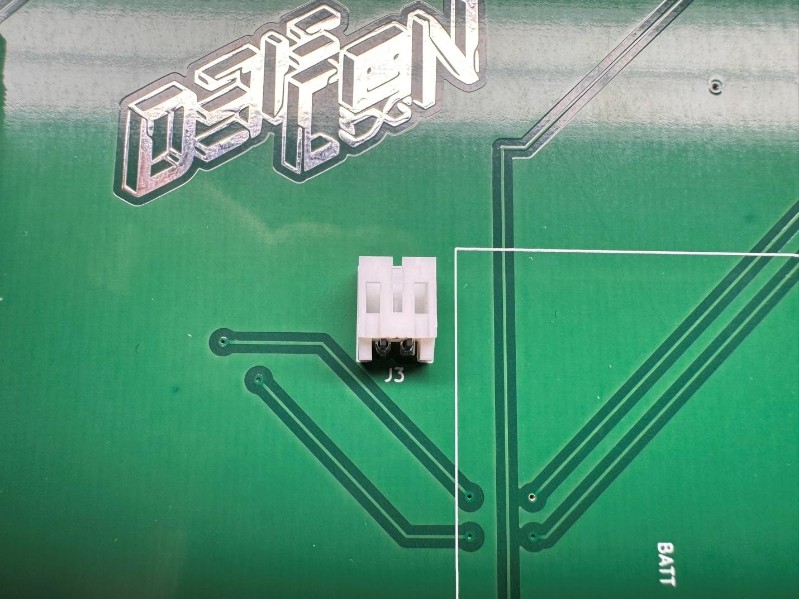
19. Trim the speaker wires leaving a few inches and run the speaker wires through the holes as shown for strain relief 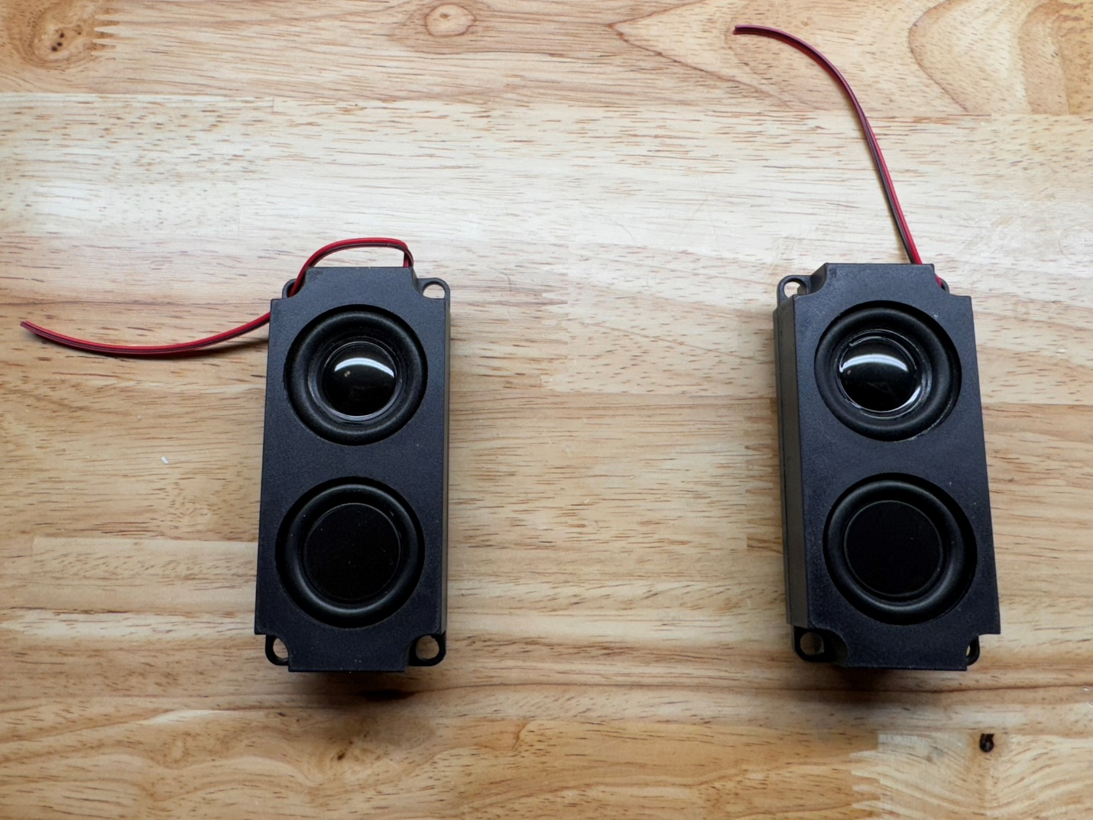
20. Cut two pieces of double-sided foam for speaker mounting (leave enough for a third piece for battery mounting)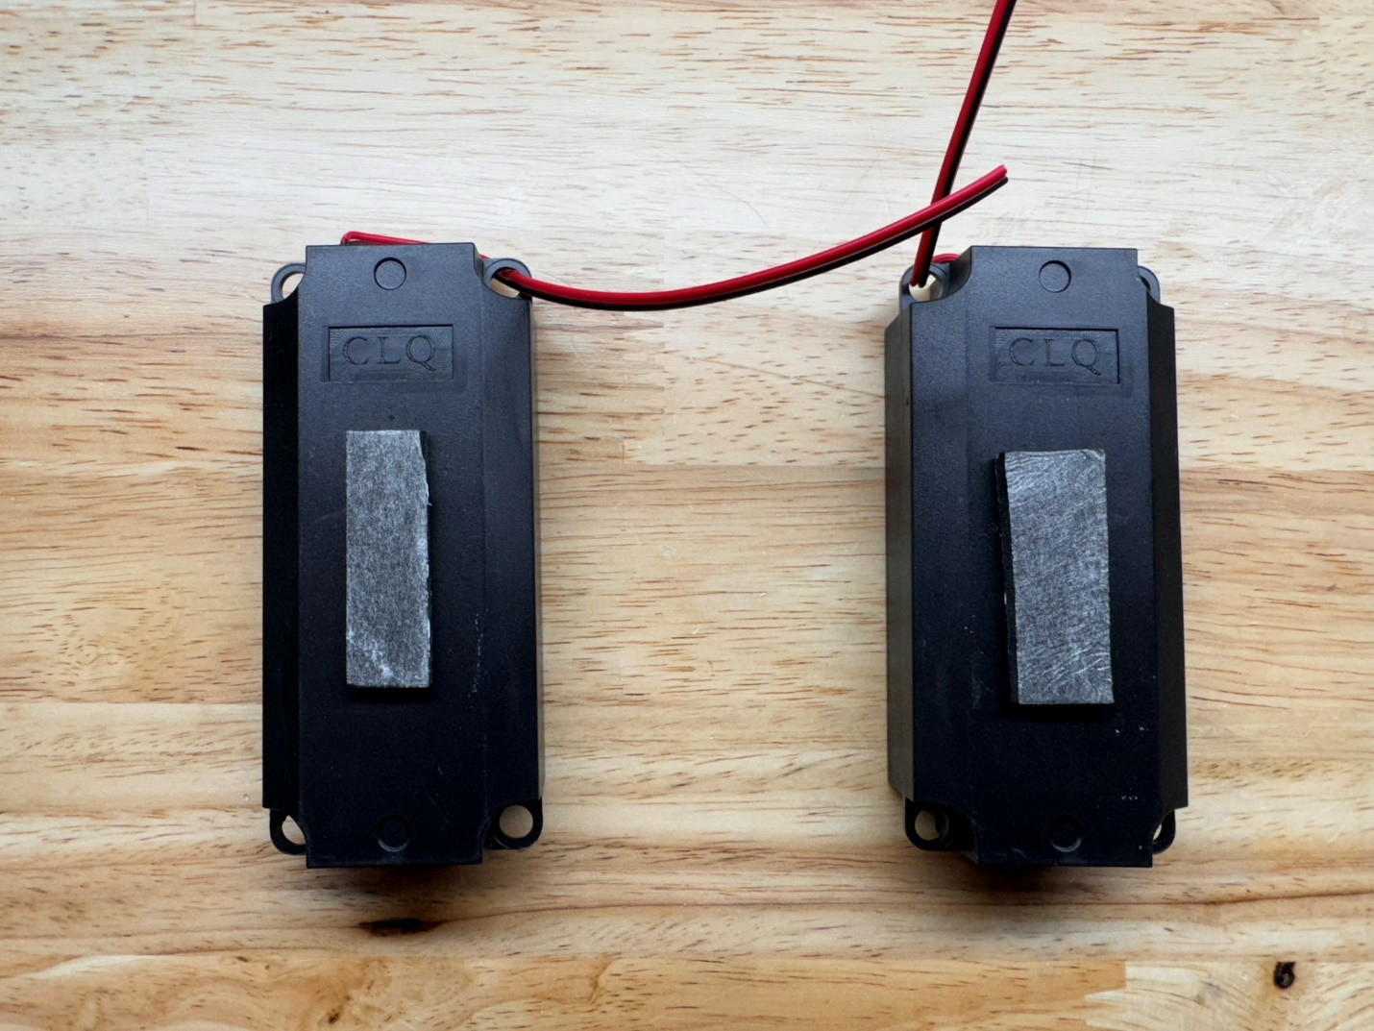
21. Mount the speakers to the badge using the foam tape by standing the badge and speakers upraight before pressing them together so it balances and doesn’t tip over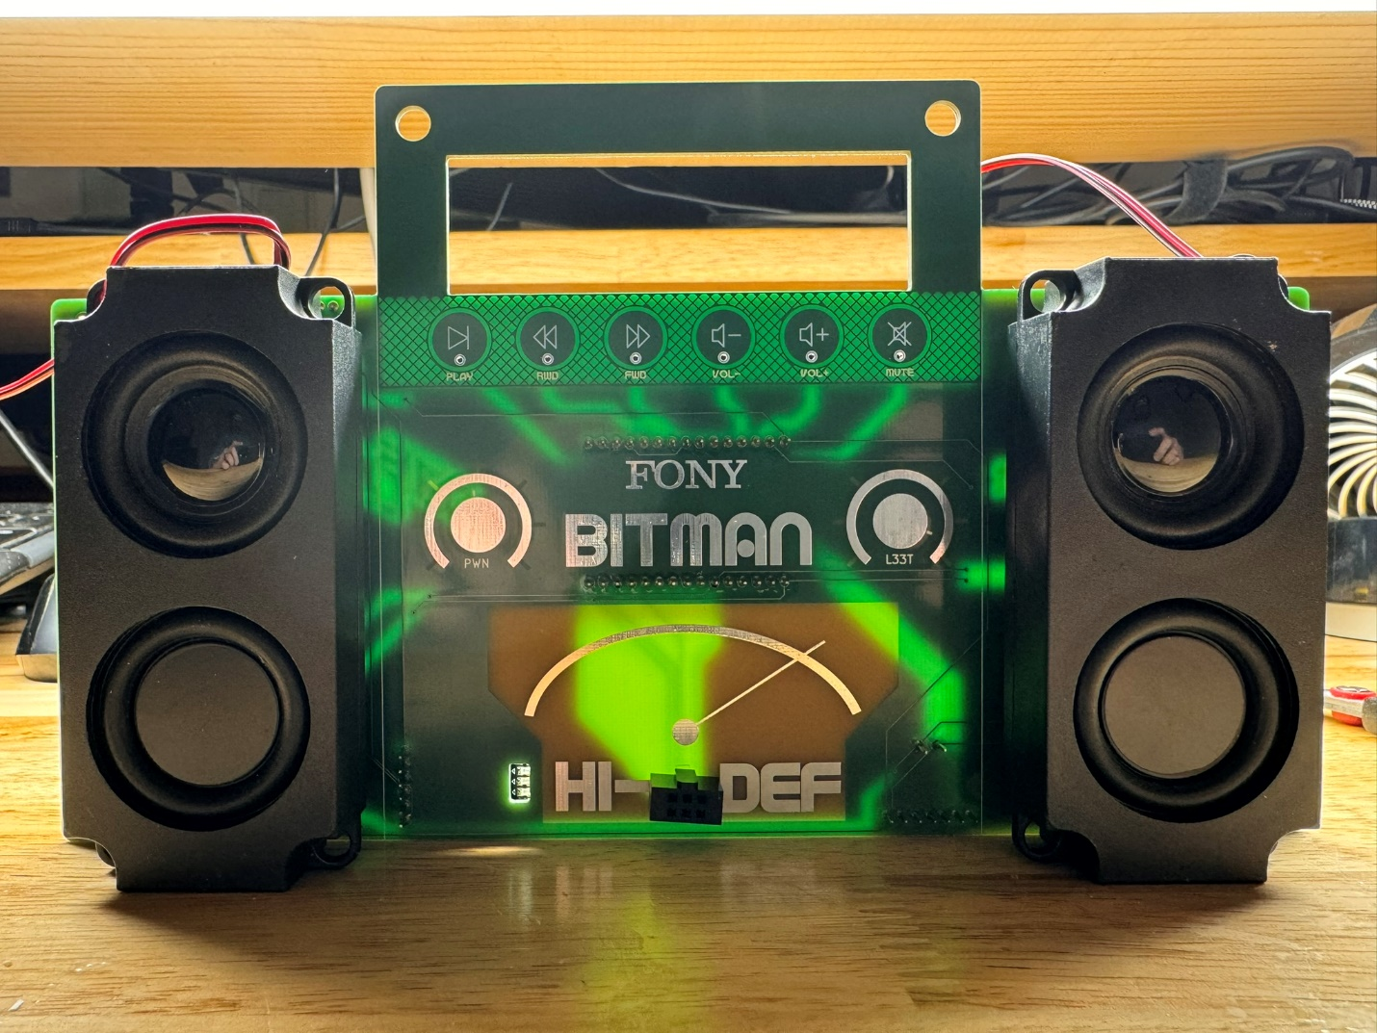
22. Split and trim the speaker wires to solder to the badge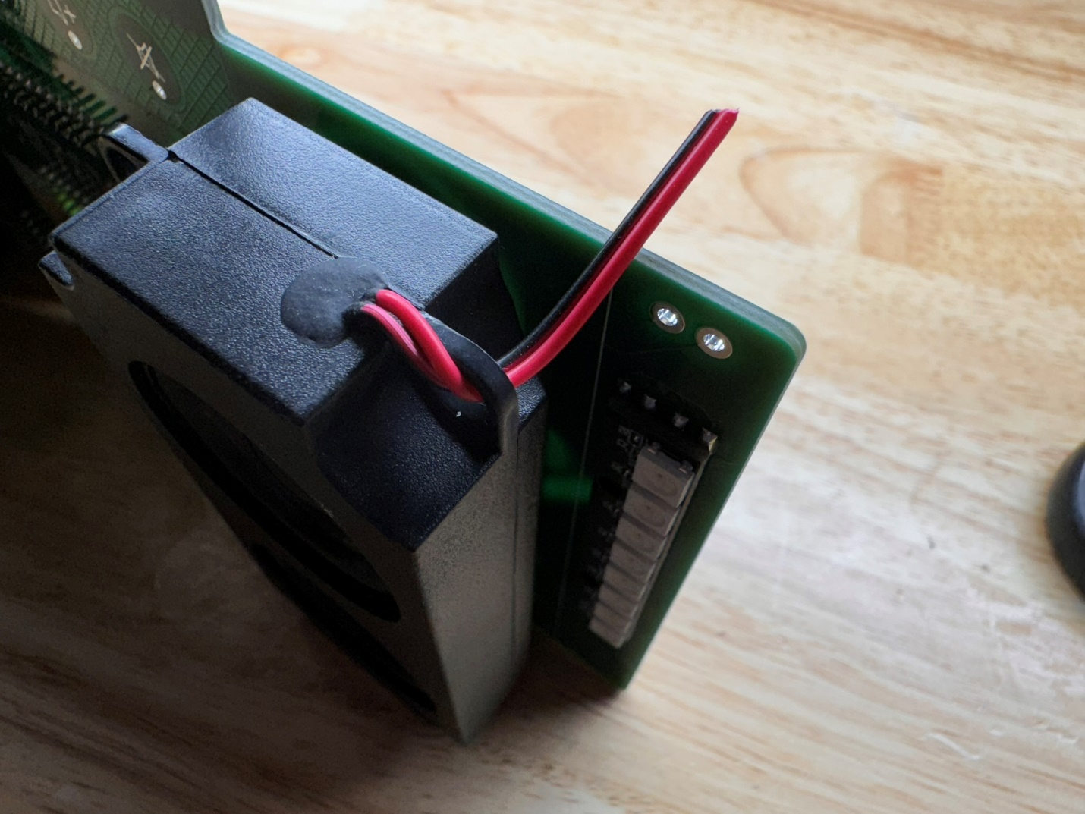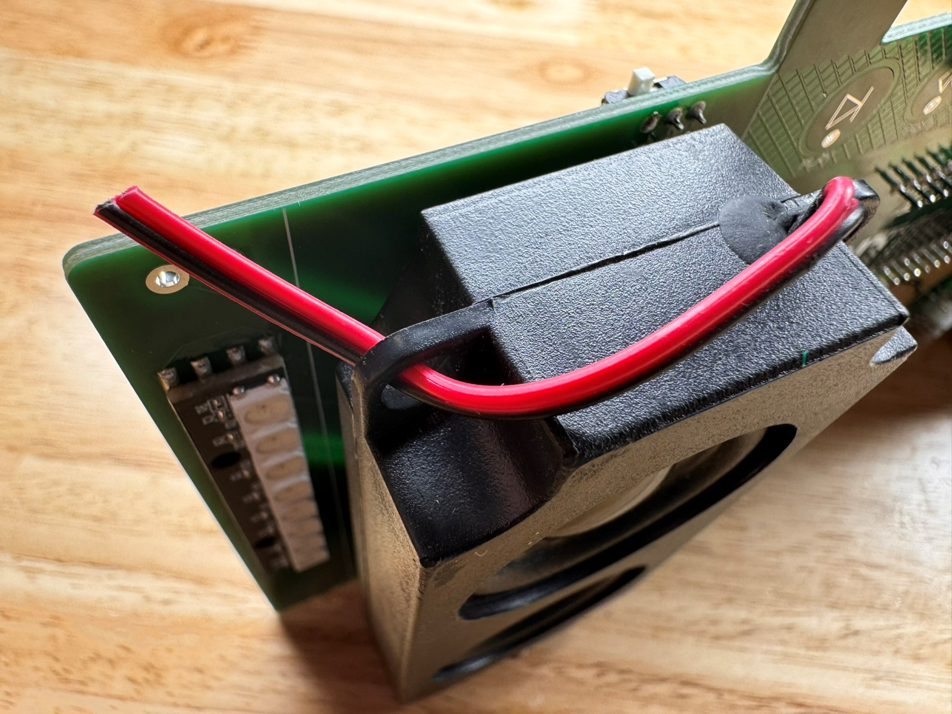
23. Solder the speaker wires to the badge noting polarity – red to (+) and black to (-)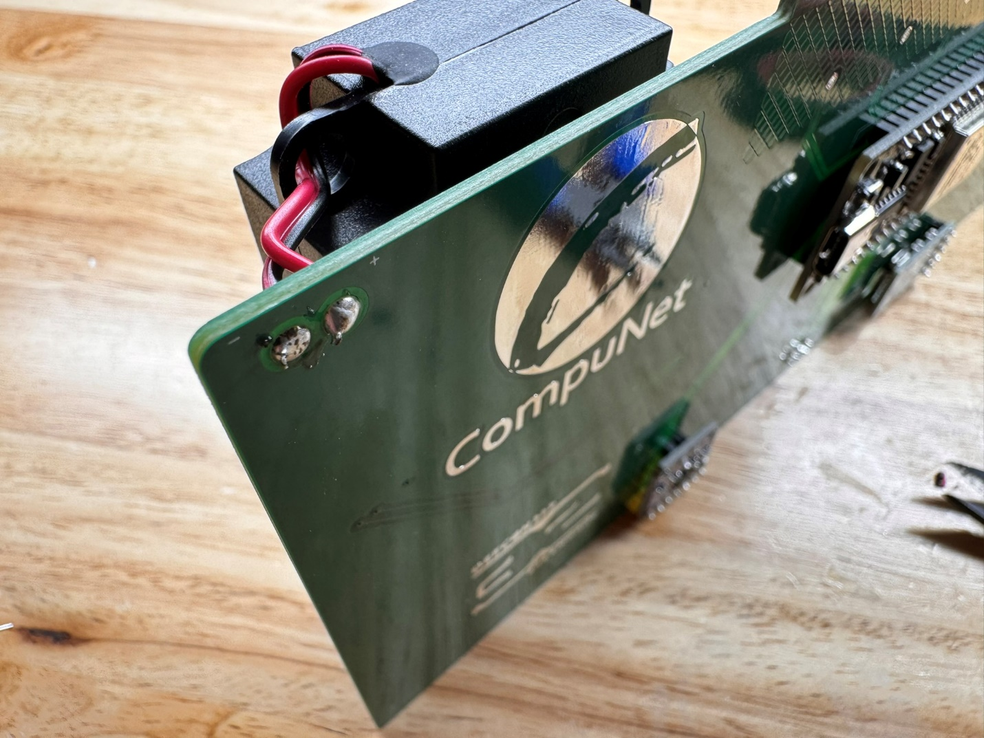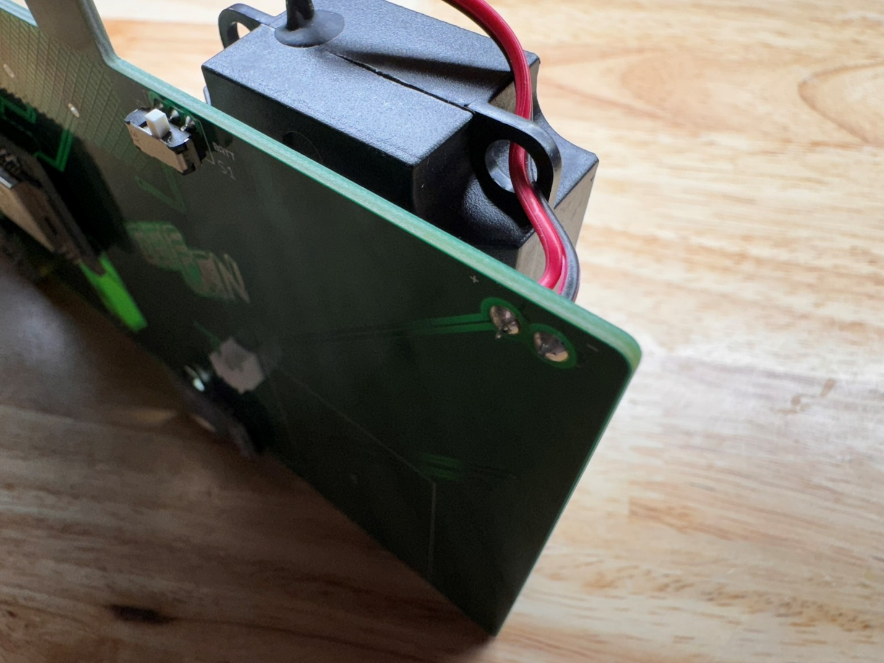
24. Locate the battery, JST PH 1.25 and JST PH 2.0 pigtail leads and 2 pieces of heat shrink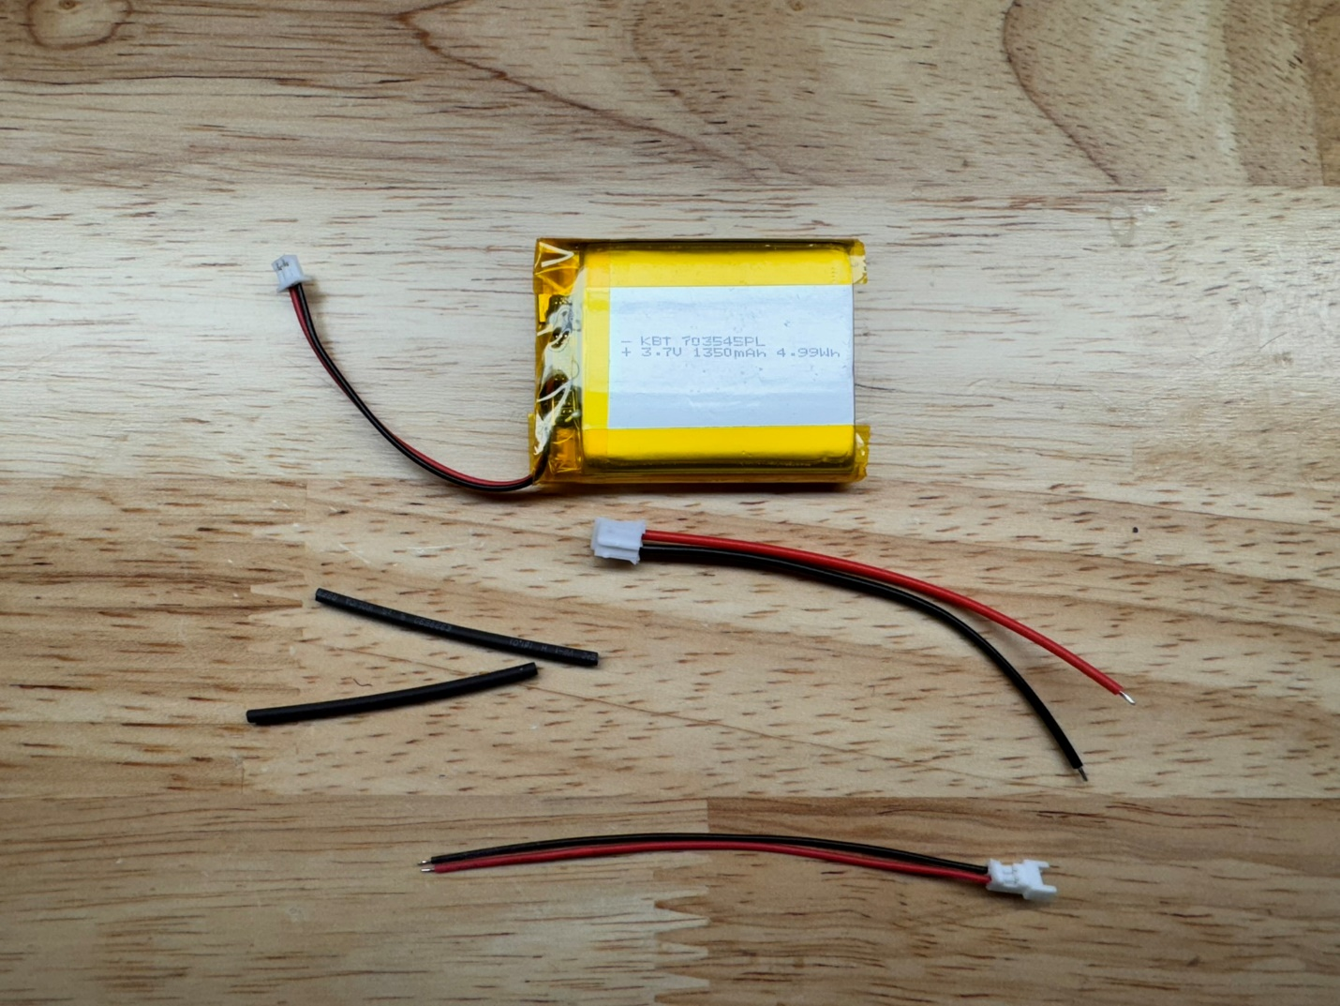
25. Slip the 2 pieces of heat shrink onto the JST PH 2.0 pig tail (fatter wires) 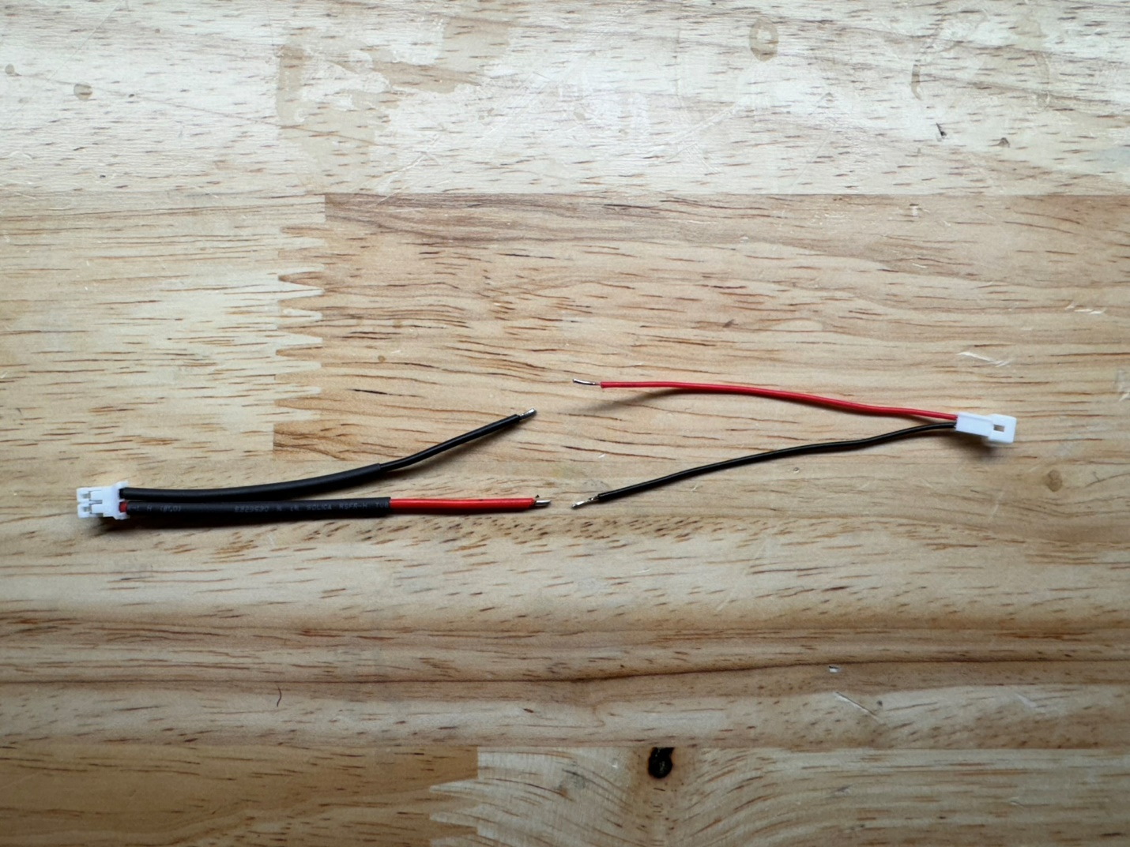
26. !!!\*\*\*IMPORTANT\*\*\*!!! Due to a part change with the battery we need to flip the polarity of the battery leads! Missing this step will kill the battery! Solder the pigtail leads together – BLACK TO RED AND RED TO BLACK! 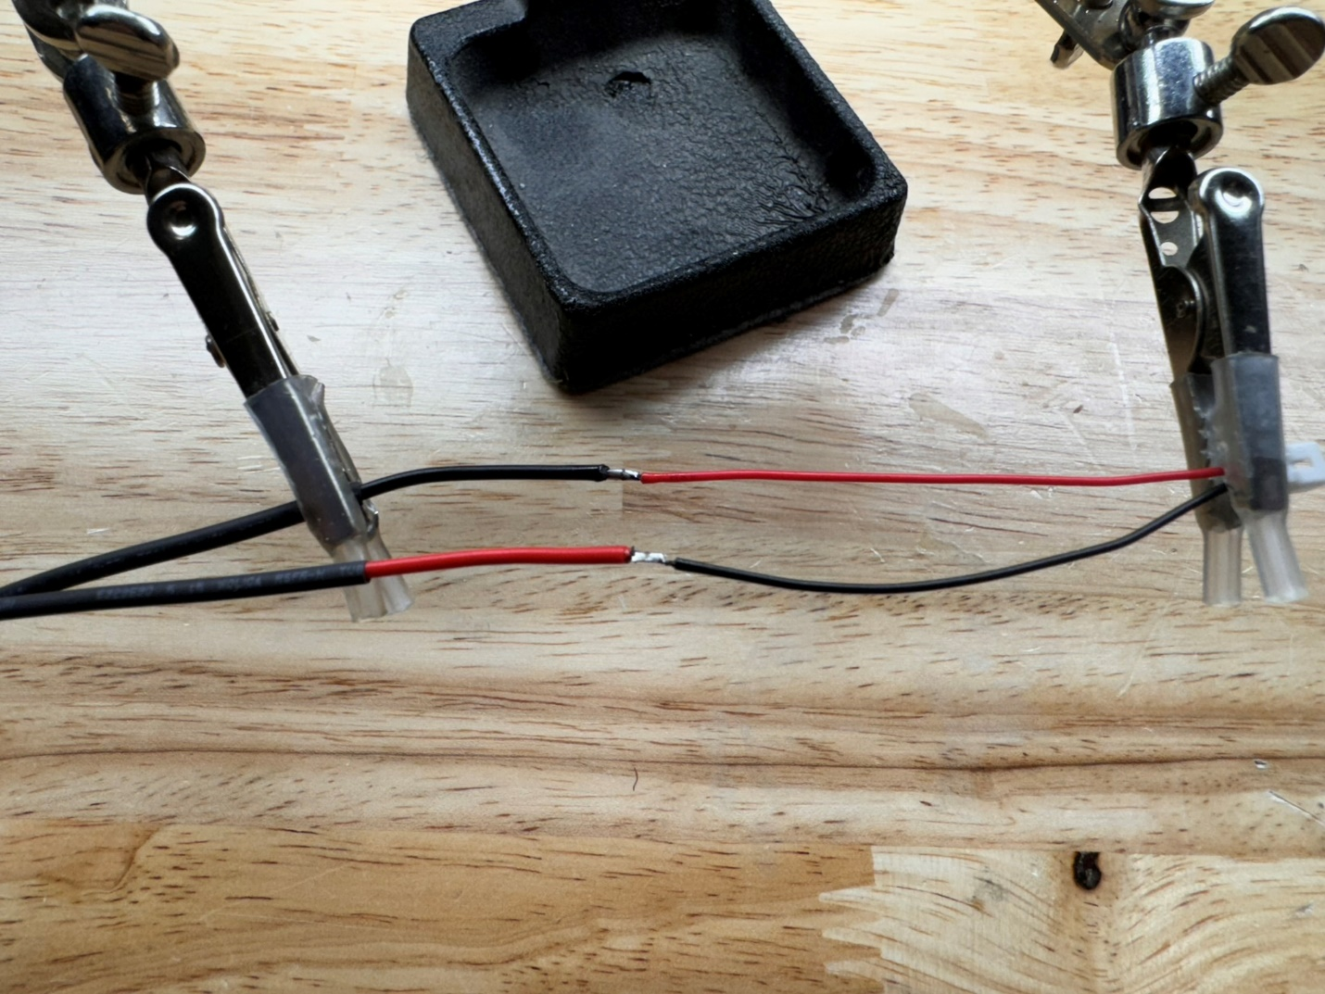
27. Shrink the heat shrink over the solder joints with a lighter or heat gun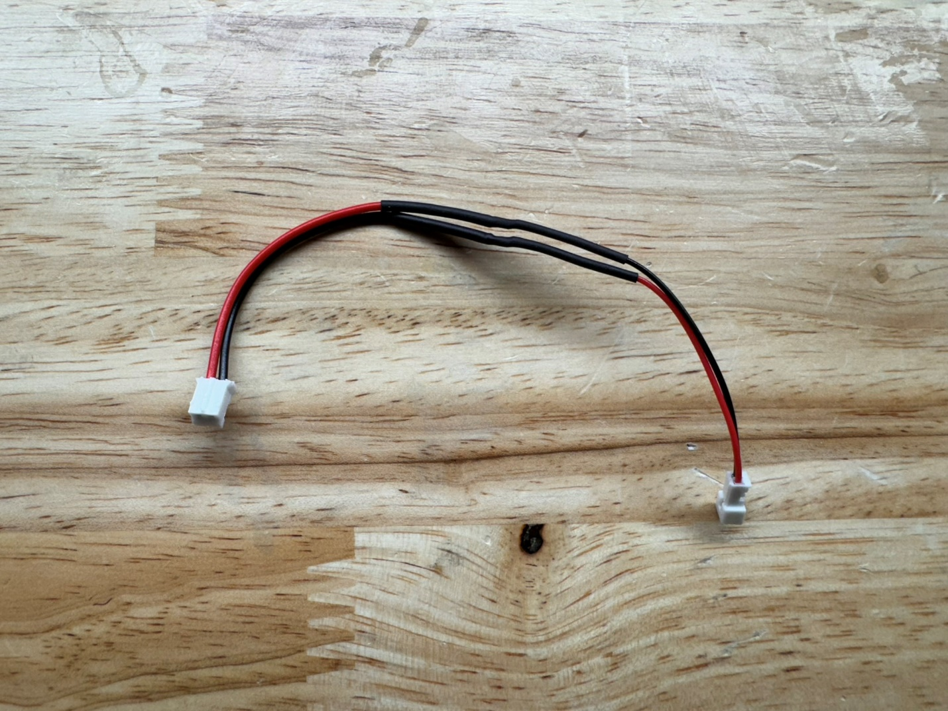
28. Place the last piece if the double sided tape in the battery location on the back of the badge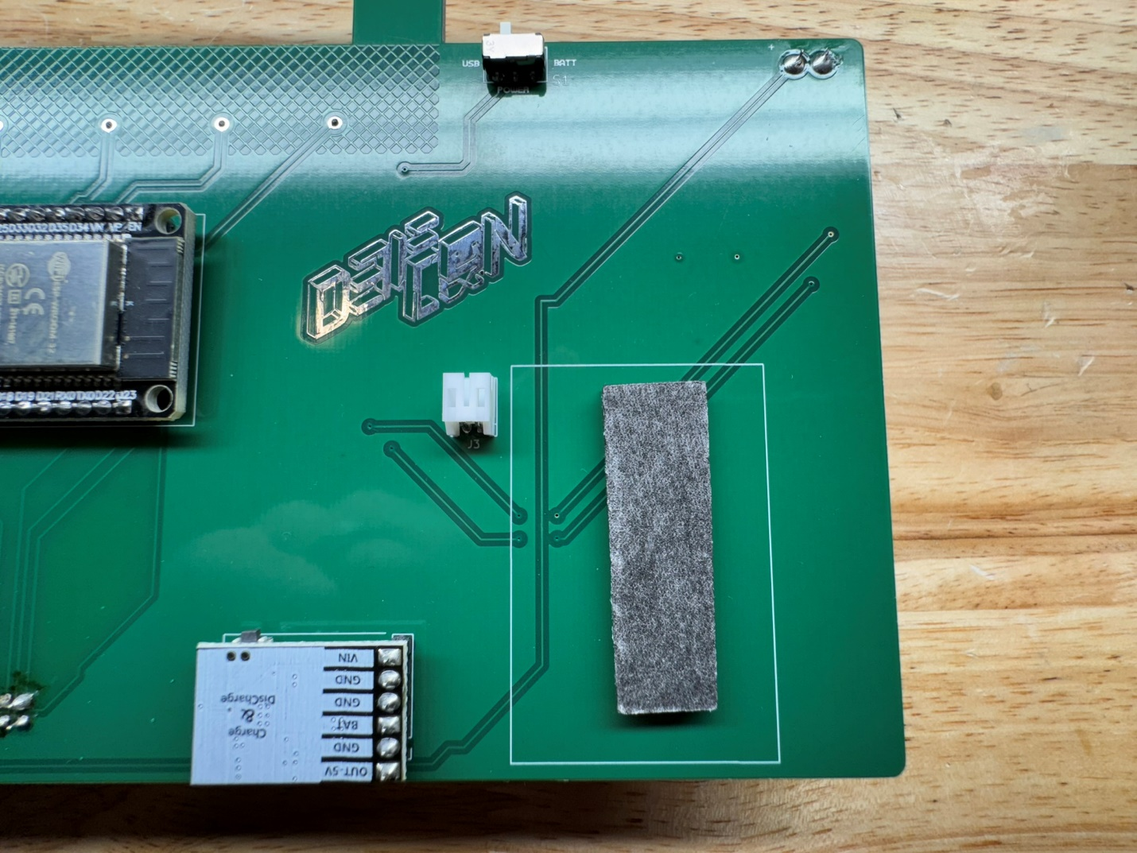
29. Route and connect the battery leads using the pigtail connector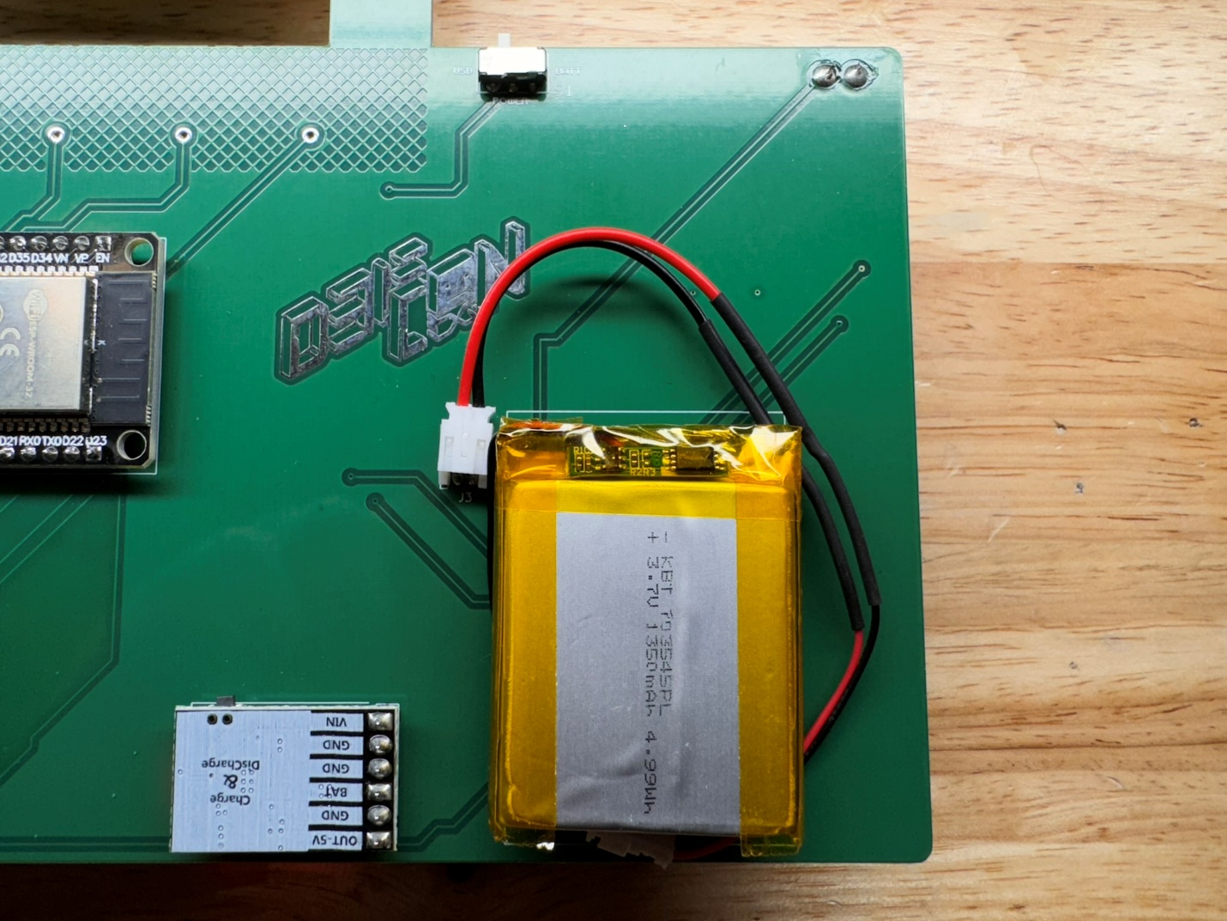

Programming the Microcontroller

1. Download the badge repo and unzip somewhere on your local drive:
   1. <https://github.com/slash128v6/DC32_CNet_Badge>
2. Open the Arduino badge sketch from the Software directory in the Arduino IDE.
3. Add the following to "Additional Boards Manager URLs" in preferences:
   1. <https://espressif.github.io/arduino-esp32/package_esp32_index.json>

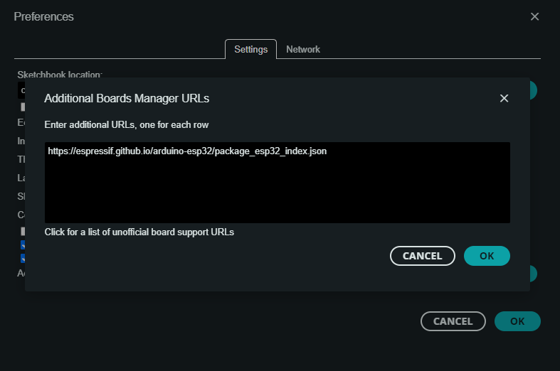

1. In Boards Manager search for esp32 and install "esp32 by Espressif Systems" version 2..0.12.

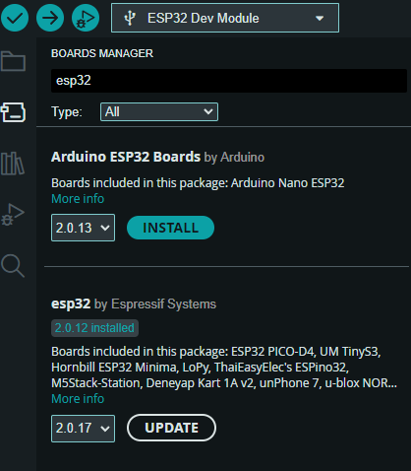

1. Install the ESP32-A2DP Bluetooth library from the pschatzmann folder via Sketch->Include Library->Add ZIP Library.
2. 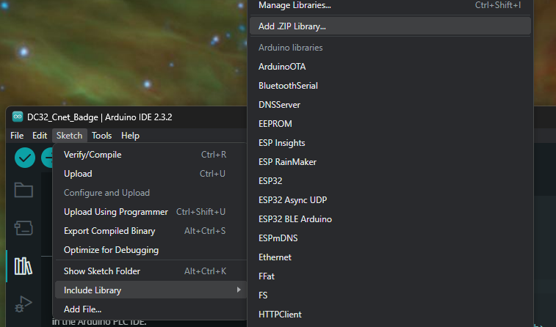

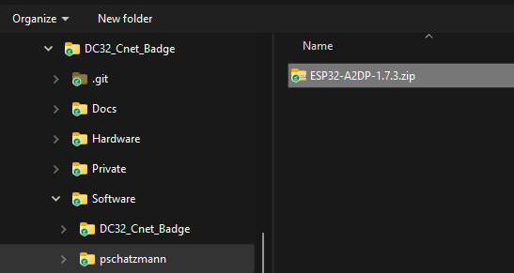

1. Set the power switch to USB and connect via USB data cable.

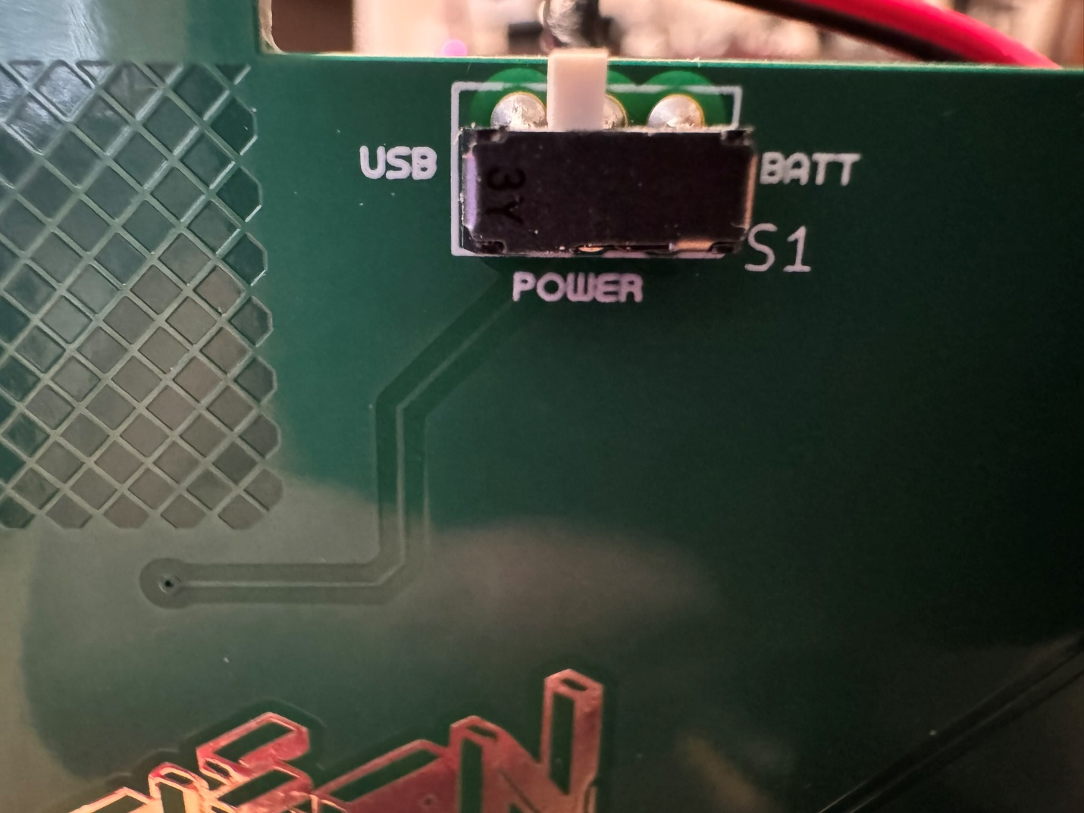

1. Note the COM port detected in Device Manager and select that port in the Arduino IDE.

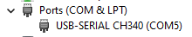

1. Click on the board selection, then “Select other board and port…” and choose ESP32 Dev Module on your connected COM port.

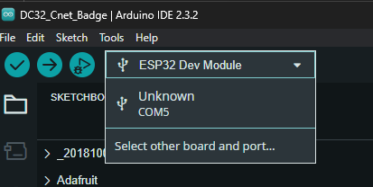

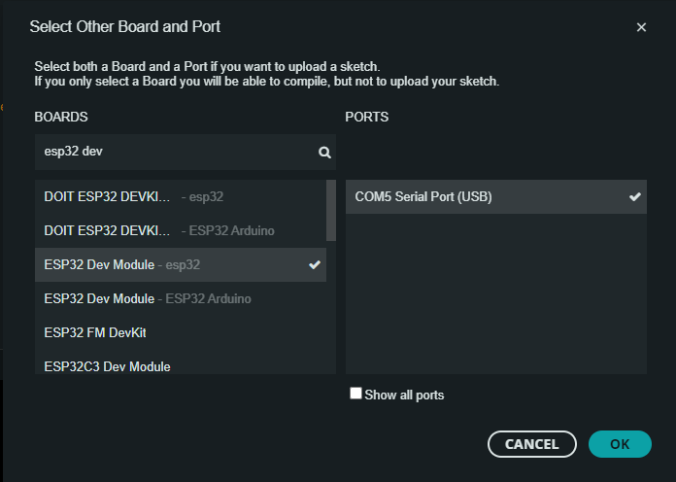

1. Click the Upload button to upload the sketch.

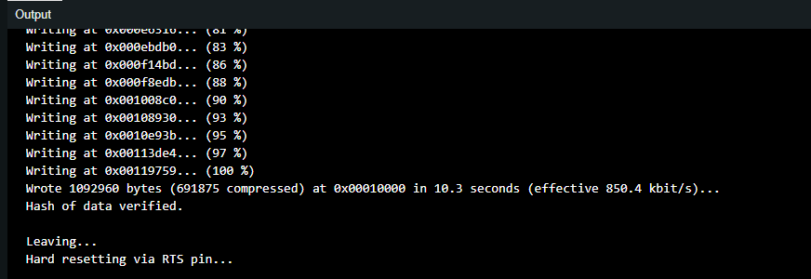

Operating the Badge

The power switch selects battery power or USB power. USB power will charge the battery. The battery must be sufficiently charged for batter operation. If the badge does not operate on battery power let it charge via USB. There is a battery “gas gauge” on the charge module that is viewable from the front of the board.

From your phone connect to Bluetooth device “Fony Bitman”. Sound should play through the speakers and the LED strips should react to the music. The touch pads on the top front of the badge should act as music and volume controls.

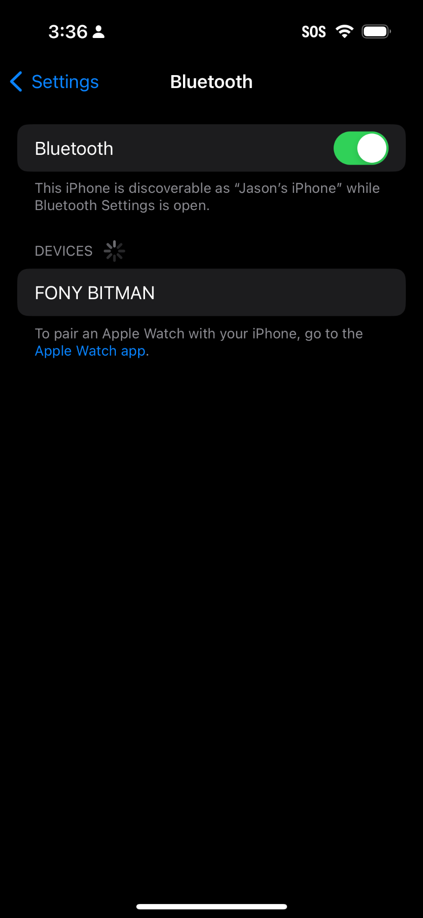

Assembling the Cassette SAO

1. Front view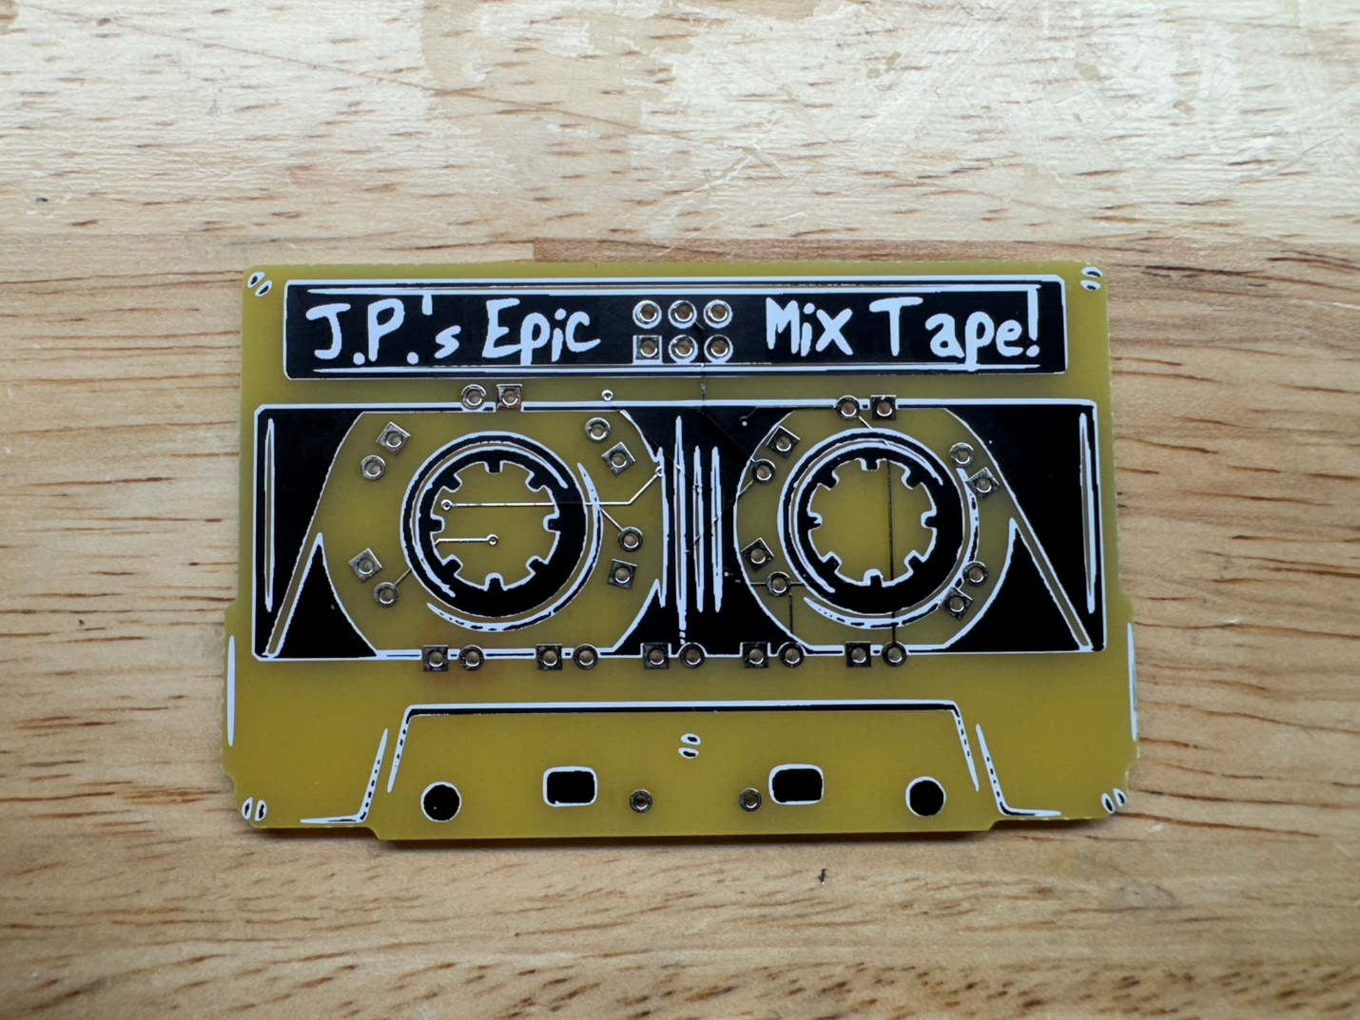
2. Rear view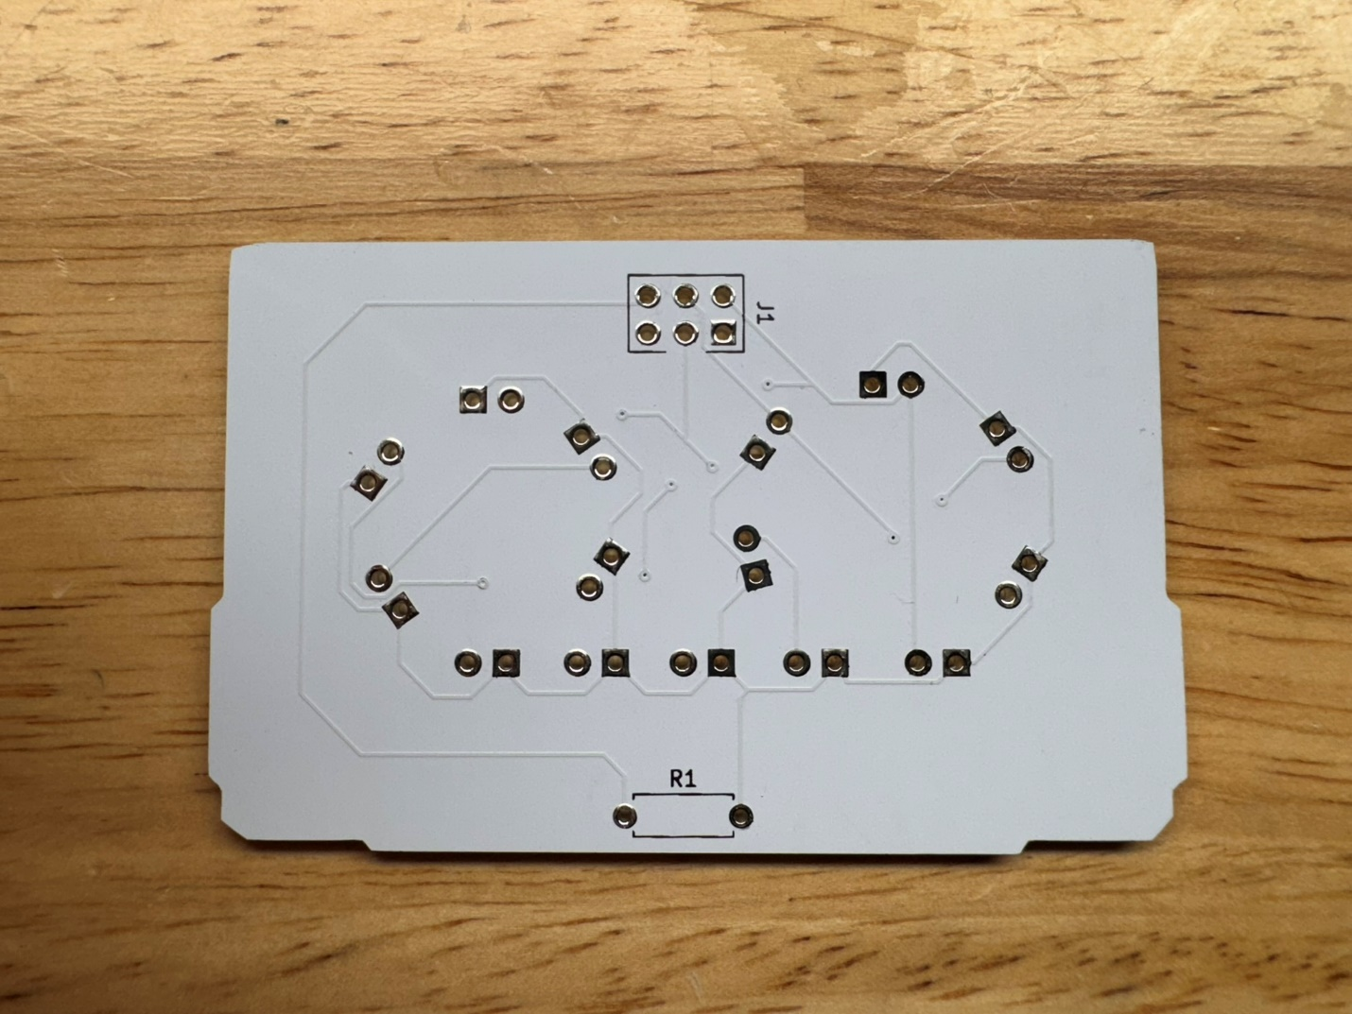
3. Solder R1 to the back of the SAO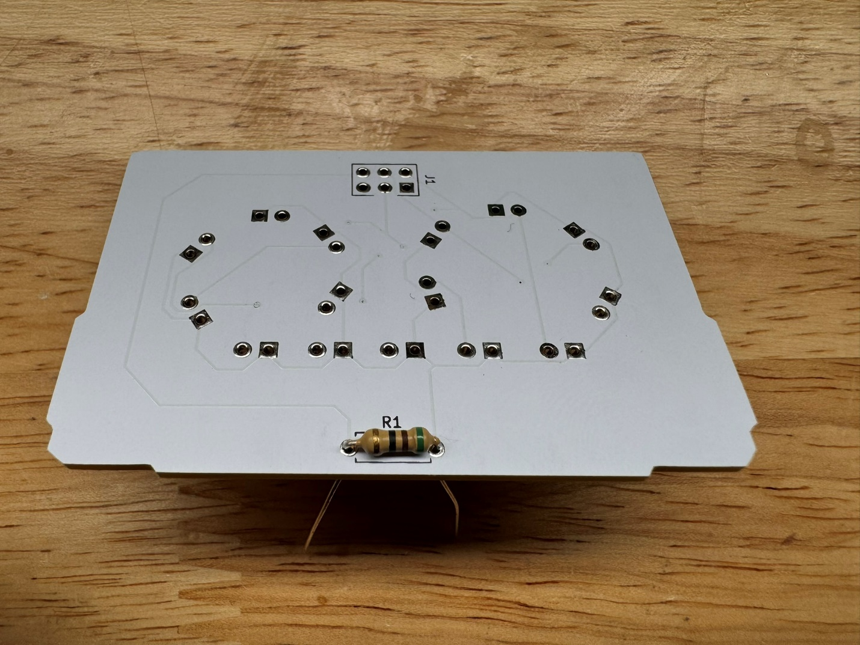
4. Trim the leads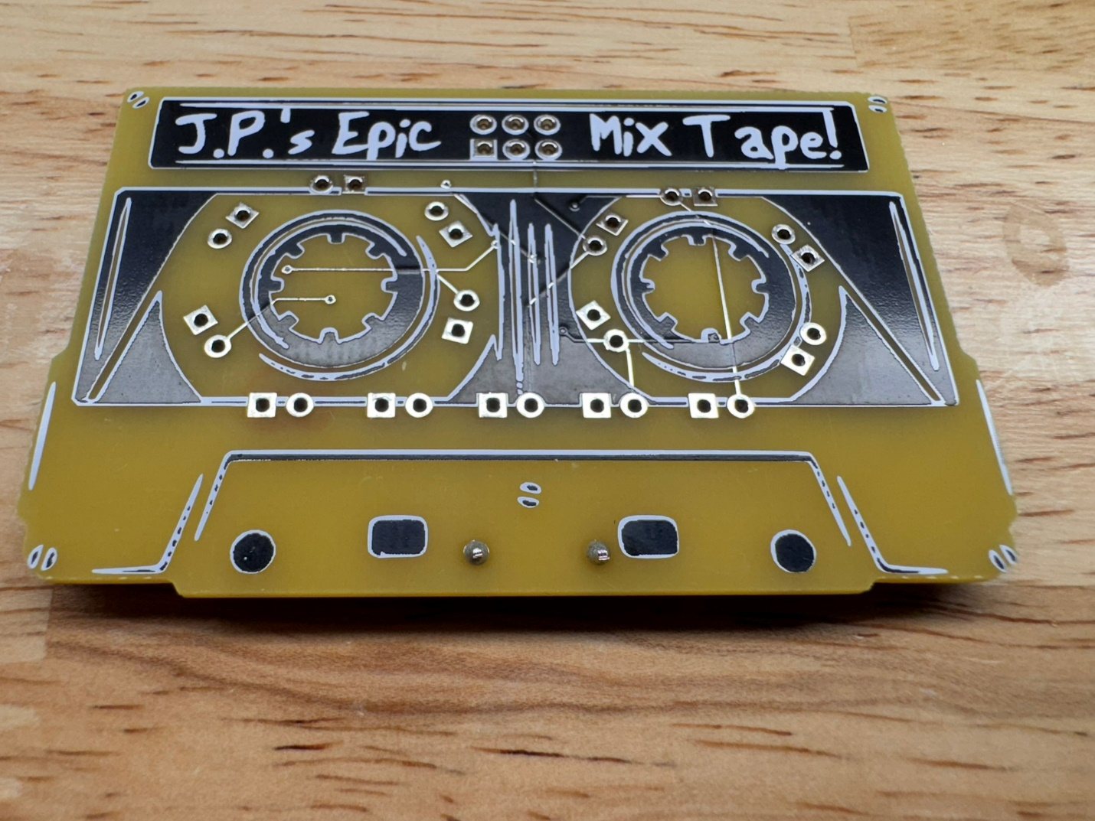
5. Solder the SAO header matching the notch orientation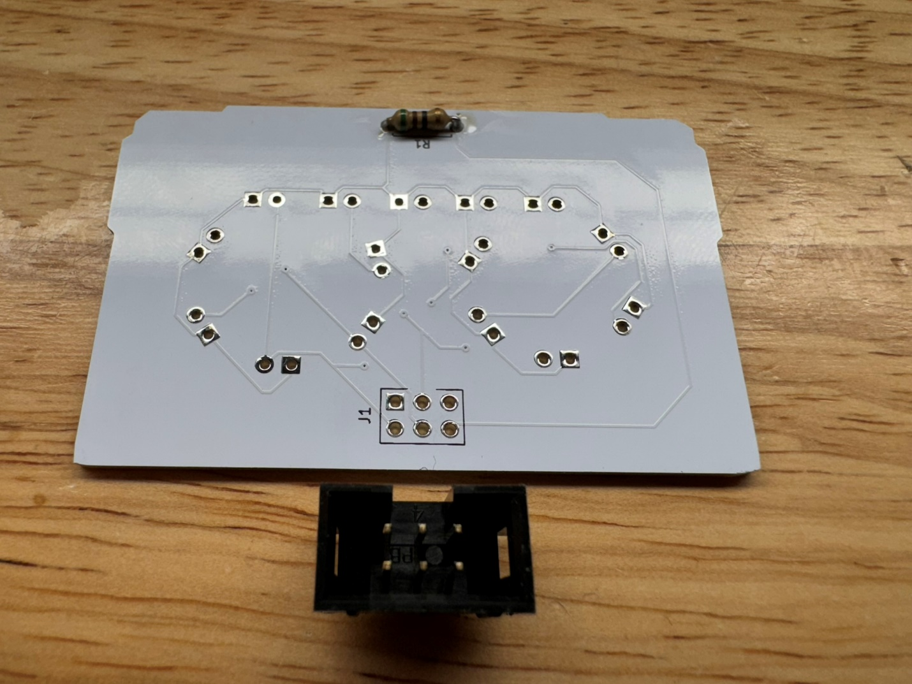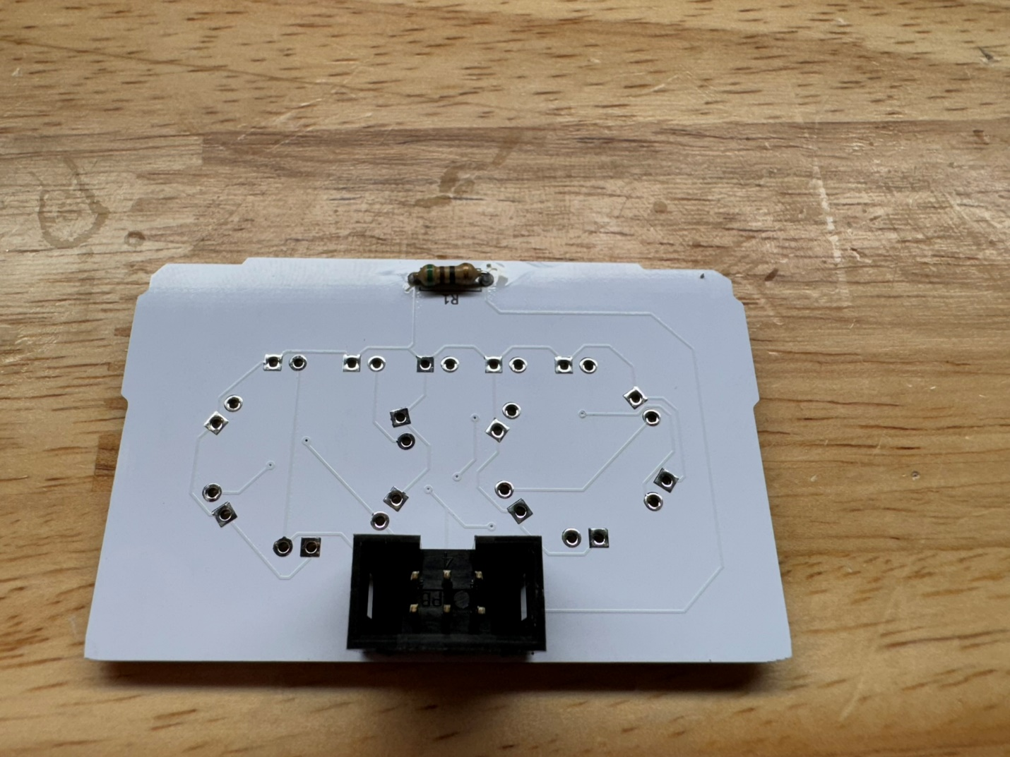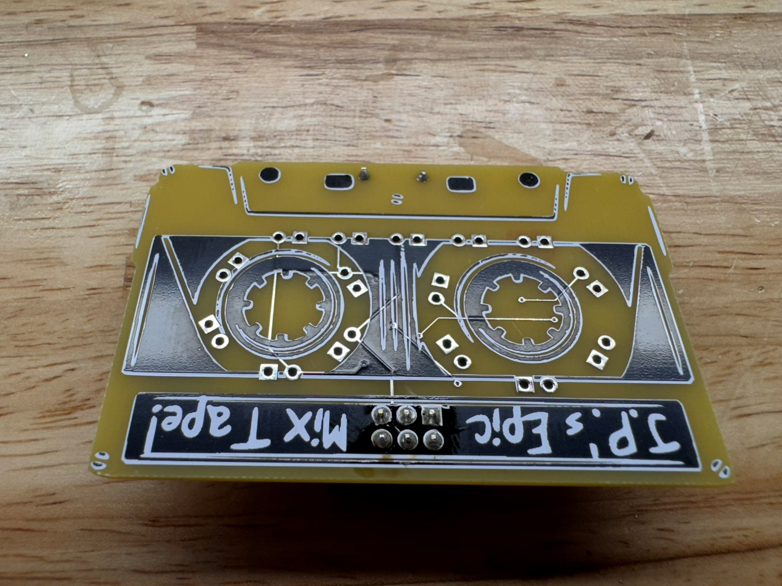
6. Solder the 15 rectangular LEDS noting the polarity – the shorter leads goes in the square holes, longer leads in the round holes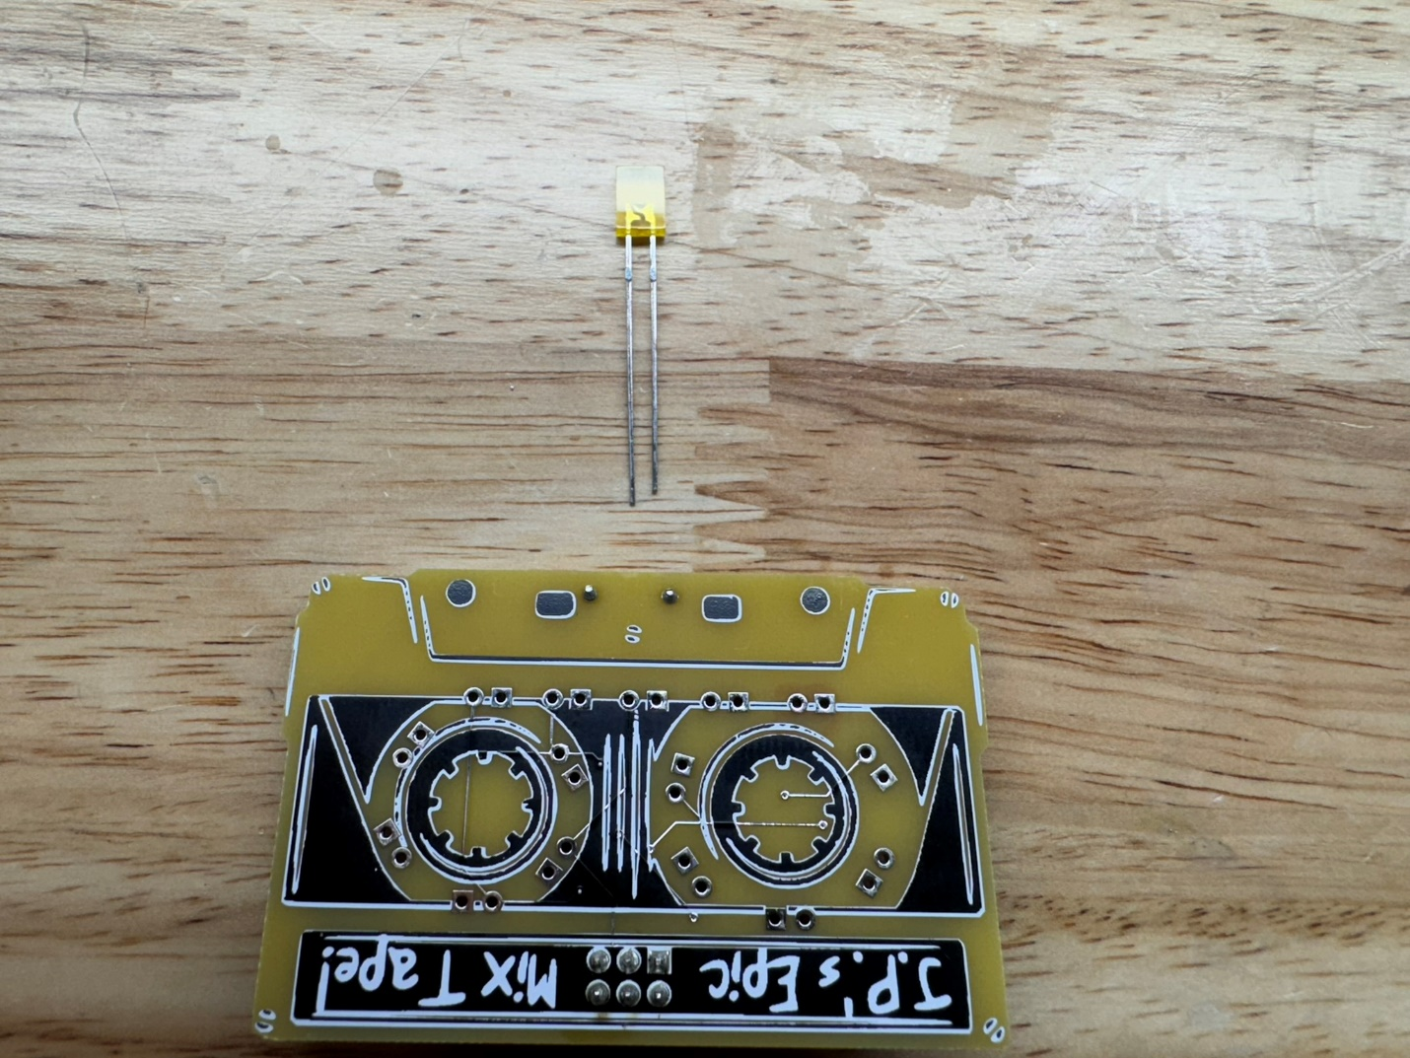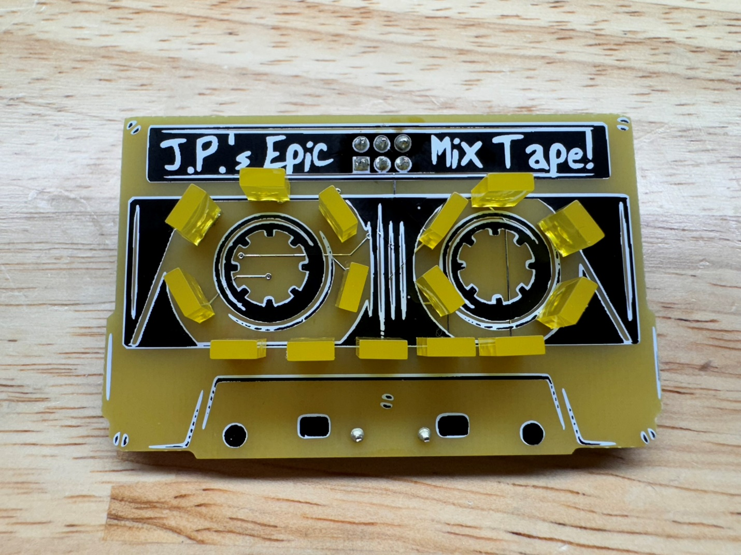
7. Trim the leads on the back